

# Organisation and Product Information

Table 1: Organisation and Product Information

|  |  |  |
| --- | --- | --- |
| Organisation Name | CBRE Pty Ltd | |
| Name of the subject(s) of certification | CBRE Pty Ltd Australian operations | |
| Type of certification (tick all applicable) | Organisation  Part of organisation | Product/service  Event |
| Reporting year period | From 1/01/2015 | To 31/12/2015 |
| Emissions in this reporting year | 3253.89 t CO2-e | |
| Base year period[1],[2] | From 1/01/2014 | To 31/12/2014 |
| Emissions in the base year | 2880.44 t CO2-e | |

# Description of Organisation Activities

CBRE Group, Inc. (NYSE:CBG), a Fortune 500 and S&P 500 company headquartered in Los Angeles, is the world’s largest commercial real estate services and investment firm (in terms of 2012 revenue). The Company has approximately 37,000 employees (excluding affiliates), and serves real estate owners, investors and occupiers through more than 300 offices (excluding affiliates) worldwide. CBRE offers strategic advice and execution for property sales and leasing; corporate services; property, facilities and project management; mortgage banking; appraisal and valuation; development services; investment management; and research and consulting. Please visit our website at www.cbre.com.

CBRE Group, Inc manages a global business through a number of regions. The Pacific region consists of Australia and New Zealand and is managed from a head office in Sydney, Australia. Sustainability and carbon issues for the Pacific are managed by a regional Head of Sustainability (Pacific) who communicates regularly with the global CBRE Sustainability Steering Committee and various practice groups.

CBRE does not own any property in its own right, in the Pacific region. It is a tenant in many locations across Australia and New Zealand. The footprint in this paper is in regards to the tenancies that CBRE occupies in the Pacific region, not the properties which we manage for clients.

# Organisational & Geographic Boundary/ Scope & system Boundary

|  |  |
| --- | --- |
| Boundary consolidation approach: | Operational control |
| Description of the boundary of the subject of certification (also describe exclusions from the boundary): | CBRE Pty Ltd have defined the organisational boundary according to the NGER Act 2007, based on facilities under operational control within the Australian geographic boundary. CBRE’s Australian business consists of wholly owned businesses with several *“Pty Ltd”* companies reporting up to one central management structure. All Australian entities (26 in total) are included in this reporting. See Appendix A for a full list of Australian entities. |

# Diagram of the Boundary of the Subject of Certification

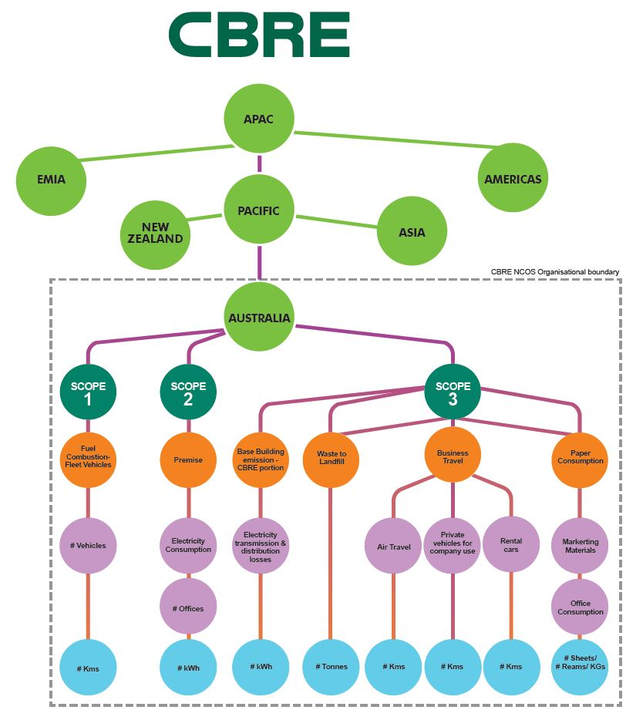

# Purchase of GreenPower and Retirement of GreenPower Eligible Large-Scale Generation Certificates (LGCS)

Table 2: GreenPower

|  |  |  |  |  |
| --- | --- | --- | --- | --- |
| Type | Volume | Unit | t CO2-e | Status |
| GreenPower | nil | - | nil | Choose an item. |

Table 2: LGCs Surrendered

|  |  |
| --- | --- |
| Details of LGCs Voluntarily Surrendered | |
| Quantity | Serial No. |
| nil | - |

# Purchase of NCOS Carbon Neutral Products

Table 3: Carbon Neutral Products

|  |  |  |  |  |
| --- | --- | --- | --- | --- |
| Product/service | Company | Quantity | Units | t CO2-e (if known) |

|  |  |  |  |  |
| --- | --- | --- | --- | --- |
| Paper | Staples / Corporate Express Carbon Neutral paper | 36,571.2 | kg | 0 |
| Total (if known) | | | | 0.0 |

# Total Carbon Footprint

Table 4: Emission Calculations

| Scope | Emission source | Source of activity data | Methodology reference | Energy content factor | Emission factor | Activity data[3] | Unit[4] | t CO2-e[5] |
| --- | --- | --- | --- | --- | --- | --- | --- | --- |
| 1 | Fuel consumption – vehicle fleet | Log books, initial and final reading checks | Australian government Green Vehicle Guide – www.greenvehicleguide.gov.au | 34.2 kg/GJ | Varies between vehicles from 0.0890 – 0.3000 kgCO2-e. Refer supporting information. | 70,381 | km | 1.25 |
| 1 | Business travel – personal vehicles for work purposes | Activity data from personal log books. | DEFRA guidelines Annex 6 (April 2012), distances defined by EPA Victoria guidelines. Refer supporting documentation. | 34.2 kg/GJ | Varies based in distance and class of travel. Refer supporting information. | 38,829.38 | km | 10.48 |
| 1 | Fuel combustion – taxi use | Activity data from accounts department | Average taxi charge per km travelled defined in EPA Victoria guidelines, Australian government Green Vehicle Guide, ATO drivers and taxi operations 2013. Refer supporting documentation. | 26.2 kg/GJ | 5 kgCO2-e. Refer supporting information. | 252,605.05 | km | 46.54 |
| 2 | Purchased electricity | Utility invoices; landlord statements | NGERS Method. NGA factors 2014, Table 5, p. 20 | Not applicable | Varies based on state. Refer supporting information. | 1,368,706 | kWh | 1,298.53 |
| 3 | Business Travel – air (direct and indirect) | Activity data from travel management company. | DEFRA guidelines 2014 Table 27, distances defined by EPA Victoria guidelines. Refer supporting documentation. | Not applicable | Varies based on distance and class of travel. Refer supporting information. | 11,239,819.4 | km | 1,637.18 |
| 3 | Business Travel – personal vehicles for work purposes | Activity data from personal log books. | DEFRA guidelines Annex 6 (April 2012), distances defined by EPA Victoria guidelines. Refer supporting documentation. | 34.2 kg/GJ | Varies based in distance and class of travel. Refer supporting information. | 38,829.38 | km | 0.59 |
| 3 | Fuel combusted to generate energy – vehicle fleet | Log books, initial and final reading checks | Australian government Green Vehicle Guide – www.greenvehicleguide.gov.au | 34.2 kg/GJ | 5.3 kgCO2-e. Refer supporting information. | 70,381 | km | 0.10 |
| 3 | Fuel combusted – taxi use | Activity data from accounts department | Average taxi charge per km travelled defined in EPA Victoria guidelines, Australian government Green Vehicle Guide, ATO drivers and taxi operations 2013. Refer supporting documentation. | 26.2 kg/GJ | 5 kgCO2-e. Refer supporting information. | 252,605.05 | km | 2.78 |
| 3 | Paper purchased | Invoices; printers activity data. | EPA Victoria Information Bulletin, incl “Greenhouse Gas Emissions Factors for Office Copy Paper” | Not applicable | 1.3kg CO2-e / kg paper OR 0.0 for NCOS certified carbon neutral paper | 43,197.1 | kg | 10.39 |
| 3 | Base building emissions – proportion attributable to CBRE’s occupancy |  | NGERS Method. NGA factors 2014, Table 5, p. 20 | Not applicable | Varies based on state. Refer supporting information. | 183,266.88 | kWh | 159.26 |
| 3 | Office waste to Landfill | Property managers statements | NGERS Method. NGA factors 2014, Table 42, p. 72; total emissions calculated based on average emissions per square metre | Not applicable | 1.1 kg CO2-e / kg | 16,948 | sqm occupied | 86.78 |
| Total footprint | | | | | | | | 3,253.89 |

# Non-Quantifiable and Excluded Emissions

CBRE have recognised that there are emissions produced from other sources that have not been included in the inventory scope. These emissions have not been included due to the lack of data available or due to the lack of operational control over the source.

|  |  |  |
| --- | --- | --- |
| **Scope** | **Excluded Source** | **Justification for exclusion** |
| Scope 3 | Employee commuting | Not under operational control. Emissions contribution likely to be minimal given a high proportion of staff utilise public transport. |
| Scope 3 | Purchased Goods - Stationary (Pens, Binders etc) | Accurate data is difficult to gather and makes a minimal impact to total emissions |
| Scope 3 | Refrigerant Leaks | Data not available/ we only occupy a small proportion of the building therefore emissions from refrigerant leaks would be minimal |
| Scope 3 | Cleaning services | Data is difficult to gather and makes a minimal impact to total emissions. |
| Scope 3 | Catering | Not under operational control: staff would consume these items even if not on the premises. |

# Carbon Offset Purchases and Retirement for this Reporting Period

CBRE have purchased and cancelled offsets in arrears for the 2015 reporting year. CBRE engaged with Climate Friendly and were chosen as our partner to assist with the purchase and cancelation of offsets. As energy is the largest contributor to our carbon footprint CBRE chose to purchase offsets from renewable or low carbon energy projects in developing regions with added social and community co-benefits.

* Project type and location
* Project verification and registration mechanisms
* Offset costs
* Project operating costs as an estimated percentage share of overall Project cost e.g. insurance, Project maintenance and administrative costs.

Final project selection and portfolio balancing was undertaken with results as follows:

* Jandra/Nulty Regeneration Project in Australia
* Siam Cement Biomass project in Thailand– substitution of fuel type for existing factory

We have retired 3254 tonnes CO2-e. Our carbon footprint for the 2015 reporting year is 3253.89 tonnes CO2-e.

Table 5: Offset Cancellations

|  |  |  |  |
| --- | --- | --- | --- |
| Offset type | Registry | Serial number | Quantity  (t CO2-e) |
| ACCU | Australian National Registry of Emissions Units | 3,748,162,835 - 3,748,163,469 | 635 |
| VCU | Markit | 4803-197662970-197665588-VCU-008-APX-TH-4-403-01012013-31122013-0 | 2619 |
| Total | | | 3254 |

# Emission Reduction Measures

CBRE Pacific has committed to reducing GHG emissions across our Australian operations by 10% by 2020, based on the 2014 base year. These emissions reduction targets were addressed by building on the three key programmes established during 2011:

* Sustainable IT
* Premises energy efficiency audit and improvement plans
* Education and awareness

**CBRE Sustainable IT programme**

CBRE Pacific has developed a multi-faceted programme to enhance energy efficiency and reduce emissions across the Pacific operations. The programme has been developed to achieve reductions across Scope 2 (Electricity) and Scope 3 (Paper purchased for office use) emissions and involves the introduction of new equipment and centralised changes to IT protocols and works alongside education programmes to influence employee behaviours.

* New energy efficient multi-function devices (MFD’s) have been introduced to all major CBRE offices, as planned, to replace old, inefficient printers and copiers with new devices that print, scan, copy and fax.
* “On-demand printing” has been rolled out for multi-function devices across Australia. This initiative necessitates attendance at the printing device when employees are ready to collect the print job – reducing paper wastage due to mislaid printing.
* The virtual fax service was rolled out in major offices across Australia. Faxes are received electronically at a central point then distributed by email. “Spam” faxes can be discarded without printing. This initiative will reduce paper usage and energy consumption and has allowed the retirement of 5 machines in Sydney office, expected to increase to approximately 30 across Australia.

This programme is designed to achieve emissions reductions through:

* reduction of energy consumption, reducing scope 2 emissions
* reduction in air travel, reducing scope 3 emissions
* reduction in paper use, reducing scope 3 emissions

1. **CBRE premises energy efficiency – audit and improvement plans**
2. Annually CBRE Pacific participates in the CBRE “Toward a Greener Tomorrow” sustainability survey of our office premises, based on a model developed by CBRE USA. In 2014 this was conducted, and allows for qualitative comparison of tenancy. To ensure rigour in our processes we also completed NABERS tenancy ratings for all of our office tenancies in 2014.
3. After the move to Activity Based Working (ABW) in the Sydney Head office in 2013; the expectations to reduce consumption of energy, paper and space were proven by the outstanding achievement of a 5.5 star NABERS Energy Tenancy Rating completed in 2014. Following the success of the ABW design in the Sydney office, The Melbourne CBD office moved their entire operations to a new location on 8 Exhibition Street in 2014. The significant improvements by the Melbourne office since moving to ABW have been proven by a 19% reduction in kWh consumption. All new tenancies will be modelled on the Sydney ABW model in an effort to demonstrate consistent reductions in environmental impacts.

Energy efficiency audit results and improvement plans will be presented at executive level for approval. Ongoing monitoring and return on investment analysis will continue to be presented as part of regular sustainability executive updates.

This programme is designed to achieve reduction of energy consumption, reducing scope 2 emissions.

1. **CBRE Sustainability education and awareness programme**

CBRE Sustainability is working across all areas of the business to raise awareness of climate change, the opportunities to reduce our corporate environmental footprint and how we can assist our clients to reduce their impacts. The Sustainable IT and Energy Efficiency programmes are backed up with continuing education to encourage resource efficiency (paper minimisation, energy minimisation) and recycling to reduce waste going to landfill.

In 2013 a series of online training packages were developed to inform our people of what sustainability is, what their personal responsibilities are and how they can assist clients in achieving sustainability improvements. These online packages have continued to be improved and utilised throughout 2014. The L&D programme utilises the following elements:

* CBRE Sustainability Commitments (in place, including performance targets)
* Sustainability intranet site (updated regularly)
* Annual sustainability engagement event focussed on increasing awareness of energy, resource and emissions reduction activities- Green Week
* “Poster” campaigns for all staff
* Education and assistance for Office Managers to drive improvement in the workplace
* Company-wide sustainability updates & newsletters
* CEO endorsement of sustainability initiatives through internal communications channels
* Executive level updates on initiatives and performance across energy, emissions and paper usage
* Executive level updates on project proposals, ongoing monitoring and return on investment analysis

This programme is designed to achieve emissions reductions through:

* reduction of energy consumption, reducing scope 2 emissions
* reduction in paper use, reducing scope 3 emissions
* increase in recycling and reduction in waste to landfill, reducing scope 3 emissions

Reductions are indicated in section Table 6 below – these reductions are compared to the 2014 reporting year. Please note that the 2015 GHG inventory includes new emissions sources and thus there has been no reduction in emissions compared to the base line year.

Table 6: Emission Reduction Measures

|  |  |  |  |  |
| --- | --- | --- | --- | --- |
| Emission source | Reduction Measure | Scope | Status | Reduction  t CO2-e |
| Fuel combusted | CBRE Sustainability education and awareness programme | 1 | Implemented in a past reporting period | 6.45 |
| Fuel combustion – taxi use | Sustainable IT programme; CBRE Sustainability education and awareness programme | 1 | Implemented in a past reporting period | 22.19 |
| Business Travel – personal vehicles for work purposes | Sustainable IT programme; CBRE Sustainability education and awareness programme | 1 | Implemented in a past reporting period | +5.41 |
| Purchased electricity | CBRE Sustainability education and awareness programme | 2 | Implemented in a past reporting period | +54.69 |
| Business travel - air | Sustainable IT programme; CBRE Sustainability education and awareness programme | 3 | Implemented in a past reporting period | +329.88 |
| Business travel – employee use of personal vehicles for work purposes | Sustainable IT programme; CBRE Sustainability education and awareness programme | 3 | Implemented in a past reporting period | 0.17 |
| Fuel combustion – vehicle fleet | CBRE Sustainability education and awareness programme | 3 | Implemented in a past reporting period | 0.49 |
| Taxi Use | CBRE Sustainability education and awareness programme | 3 | Implemented in a past reporting period | 2.93 |
| Base building emissions – proportion attributable to CBRE’s occupancy | Sustainable IT programme; CBRE premises energy efficiency – audit and improvement plans; CBRE Sustainability education and awareness programme | 3 | Implemented in a past reporting period | 26.51 |
| Paper purchased | Sustainable IT programme; CBRE Sustainability education and awareness programme; carbon neutral paper procurement | 3 | Implemented in a past reporting period | 36.87 |
| Office Waste to Landfill | CBRE Sustainability education and awareness programme; | 3 | Implemented in a past reporting period | +78.73 |
| Total emission reductions implemented in this reporting period  (overall figure includes sources where emissions increased) | | | | 373.47 |
| Total expected emission reductions in future reporting periods | | | | 150 |

# 11. Declaration

To the best of my knowledge and having implemented the quality controls and standards required under the NCOS Carbon Neutral Program and made all appropriate inquiries, the information provided in this Public Disclosure Summary is true and correct.

|  |  |
| --- | --- |
| Emma McMahon |  |
| Name of Signatory | Signature |
| Head of Sustainability, Pacific | |
| Position / Title of Signatory | |
| 4/11/2016 | |
| Date | |

1. First year for which the GHG Inventory has been completed – this will be considered to be the base year against which emission reduction activities will be measured.
2. For events, a reference case can be provided against which emissions may be compared.
3. Activity data refers to the actual total consumption of fuel, electricity, etc., e.g., 10,000 MWh or 1,000 kL.
4. Unit refers to the unit of measurement – e.g. MWh, kL, etc.
5. = Activity data x energy content factor (if applicable) x emission factor converted to tonnes CO2-e