**Climate Active Carbon Neutral Certification Trade Mark**  
**USER GUIDE**

2021

Image is the Climate Active logo, with two offset circular arcs and the words climate active below.

# Contents

Introduction 3

1. Rules for use 4

1.1. Definitions 4

1.2. Obtaining approval to use the Certification Trade Mark 5

1.3. Conditions for use of the Certification Trade Mark 5

1.4. Dispute resolution process 5

2. Visual style guide 6

2.1. The Certification Trade Mark 6

2.2. First use or different uses of the Certification Trade Mark 6

2.3. Certification Trade Mark variants 6

2.4. Colour options 7

2.5. Clear space 8

2.6. Minimum size 9

2.7. Certification Trade Mark do’s and don’ts 9

# Introduction

The Climate Active Carbon Neutral Standard (the Standard) is a voluntary standard that sets requirements for becoming carbon neutral in Australia. It includes rules for calculating, reducing, offsetting, verifying and reporting on greenhouse gas emissions. The Department and other entities approved by the Department (Certifiers) provide certification against the Standard.

The Standard has separate Certification Categories, depending on whether the entity wishes to certify an organisation, product, service, building, precinct or event as carbon neutral. Certification Categories may be amended, updated, added or removed as required.

Once a Certifier is satisfied that the entity meets the Standard in respect to the Certification Category, the Certifier and entity enter into a licence agreement. This agreement grants both formal certification and a licence to use the Climate Active Carbon Neutral Certification Trade Mark (Certification Trade Mark) in respect of that Certification Category.

This *User Guide for the Climate Active Carbon Neutral Certification Trade Mark* (User Guide) sets out:

* Section 1 - Rules for Use – how users may obtain approval to use the Certification Trade Mark, the conditions for its use and the dispute resolution process that an entity may use if they disagree with the decision of a Certifier in relation to the granting and use of the Certification Trade Mark.
* Section 2 - Visual Style Guide – the process for initial use of the Certification Trade Mark, and the required graphic standard for the Certification Trade Mark, including the set colours, minimum size, position and spacing.

# Rules for use

1.1. Definitions

1. Approved User means an entity that has been approved by a Certifier to use the Certification Trade Mark and has agreed to the Terms and Conditions for use of the Certification Trade Mark.
2. Certification Category means the categories that can be certified as carbon neutral against the Climate Active Carbon Neutral Standard. The following certification categories are currently available:
3. Organisations
4. Products and Services
5. Buildings
6. Precincts
7. Events

New Certification Categories may be added in the future; and current Certification Categories may be amended.

1. Certifier means the Department and other entities approved by the Department that can certify organisations, products, services, buildings, precincts and events (or other variants) as carbon neutral against the Climate Active Carbon Neutral Standard. A Certifier must have relevant expertise and experience in carbon accounting and verification, or administering a certification program. If a Certifier is not the Department, they must have a contractual arrangement in place with the Department which sets out the Certifier’s roles and responsibilities.
2. Climate Active Carbon Neutral Certification Trade Mark (Certification Trade Mark) means the Climate Active Carbon Neutral Standard Certification Trade Mark: IP Australia Reference Number: 2042153.
3. Climate Active Carbon Neutral Certification Trade Mark variants (Certification Trade Mark variant) means the variations of the Certification Trade Mark outlined at Section 2: Visual Style Guide.
4. Climate Active Carbon Neutral Standard (the Standard): A standard for making carbon neutral claims against the Certification Categories; as amended from time to time and published on the Department’s website.
5. Department means the Commonwealth Department of Industry, Science, Energy and Resources or its administrative successor.
6. Terms and Conditions means the obligations and rules in a licence or other agreement in place between an Approved User and Certifier to use the Certification Trade Mark.
7. User Guide means this User Guide.

1.2. Obtaining approval to use the Certification Trade Mark

To obtain approval to use the Certification Trade Mark an entity must:

1. apply for carbon neutral certification consistent with the relevant Standard for their Certification Category;
2. enter into a licence agreement with a Certifier, agreeing to the Terms and Conditions for using the Certification Trade Mark; **and**
3. receive approval from a Certifier to use the Certification Trade Mark or its variants.

The licence agreement amounts to both certification against the relevant Certification Category and a licence to use the Certification Trade Mark.

There are several variants of the Certification Trade Mark that can be used depending on the Certification Category. These are discussed in Section 2 of this User Guide.

Further details on the requirements and process for obtaining certification against the Standard and approval to use the Certification Trade Mark are available at: www.climateactive.org.au.

1.3. Conditions for use of the Certification Trade Mark

Approved Users authorised to use the Certification Trade Mark must do so in accordance with:

1. the Terms and Conditions agreed between the Approved User and a Certifier;
2. this User Guide, to the extent that this is not inconsistent with the Terms and Conditions.

1.4. Dispute resolution process

If an entity disagrees with a decision of a Certifier in relation to the granting and use of the Certification Trade Mark, it may request an internal review of the decision by a person who was not part of the original decision making process.

An internal review application must be made in writing within 30 days of receipt of the written notice of the decision. No fees are payable for the internal review of a decision.

There is no set form for making an application for an internal review of a decision. Nonetheless, in order to undertake the review, the written application must clearly set out both:

1. the grounds on which the decision should be reviewed; and
2. the evidence to support the application.

If information exists which was not provided to the Certifier as part of the original application, it may be provided to the Certifier for their consideration of the internal review application.

Written notification of the decision on internal review and reasons for the decision will be issued to the entity within 60 days of the receipt of the application for internal review.

# Visual style guide

2.1. The Certification Trade Mark

The Certification Trade Mark (2042153) is displayed below:



Approved Users must only use the master artwork files of the Certification Trade Mark variant supplied by the Certifier. The Certification Trade Mark variant should never be stretched or warped, keeping with the original dimensions specified in the master artwork files.

2.2. First use or different uses of the Certification Trade Mark

Before using the Certification Trade Mark or its variants for the first time or in a different way than previously approved, the Approved User must provide drafts of those new or different materials containing the Certification Trade Mark variant to the Certifier for review and approval.

The Certifier will check that Certification Trade Mark variants and placements align with the requirements in this User Guide prior to providing approval for first use. If the use does not align with the requirements in this User Guide, they may withhold approval to use the Certification Trade Mark variant until certain amendments are made.

2.3. Certification Trade Mark variants

Certification Trade Mark variants are available for use against specific Certification Categories. Approved Users may only use the variant that corresponds to the Certification Category as approved by the Certifier.

Approved Users must only use the master artwork files of the Certification Trade Mark variants supplied by the Department. The Certification Trade Mark variants should never be stretched or warped, keeping with the original dimensions as specified in the master artwork files provided by the Certifier.

The Certification Trade Mark should only be used in the colours, format and variations approved by the Department.

**Variations**

* Climate Active Carbon Neutral Product
* Climate Active Carbon Neutral Service
* Climate Active Carbon Neutral Event
* Climate Active Carbon Neutral Organisation
* Climate Active Carbon Neutral Precinct
* Climate Active Carbon Neutral Building

Horizontal versions

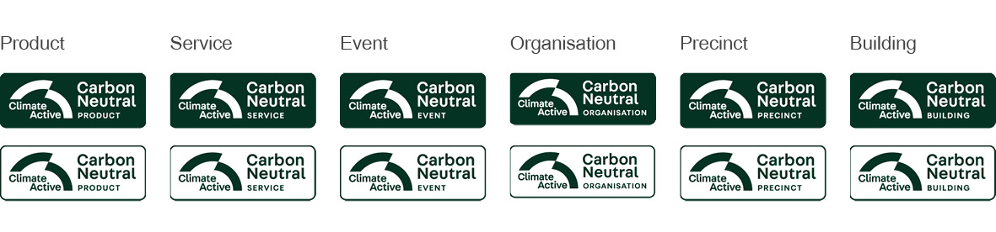

Vertical versions

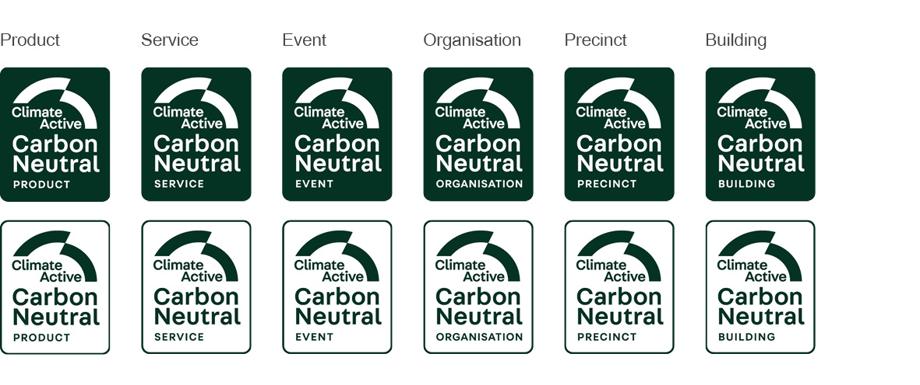

2.4. Colour options

The Certification Trade Mark and its variants must appear in Highland green, white, or black as shown below.

Highland green and black versions must adhere to the following:

* Highland green or black text and border on a white background; or
* White text on a highland green or black background.

White versions must be either a white text and border on a transparent background; or transparent text on a white background.

Variations to these specifications must be formally requested from a Certifier and will be considered on a case-by-case basis.

The details of the Highland greencolour are as follows.

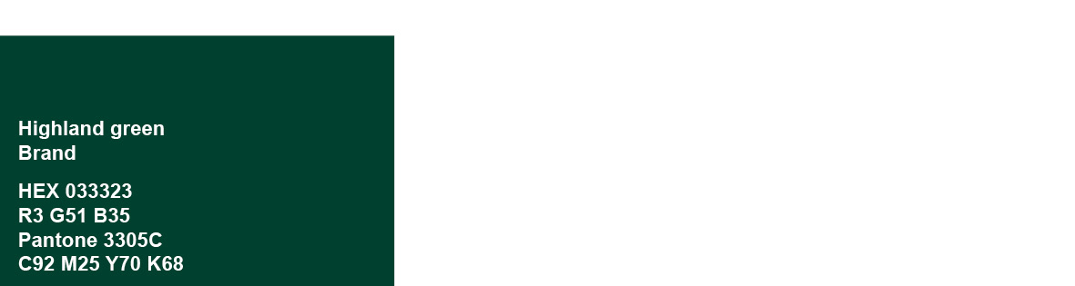

Highland Green Versions

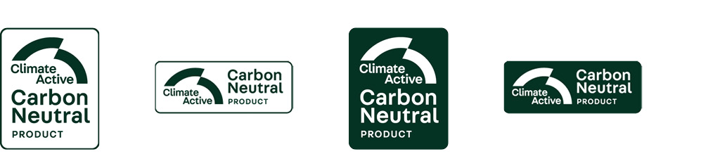

Black Versions

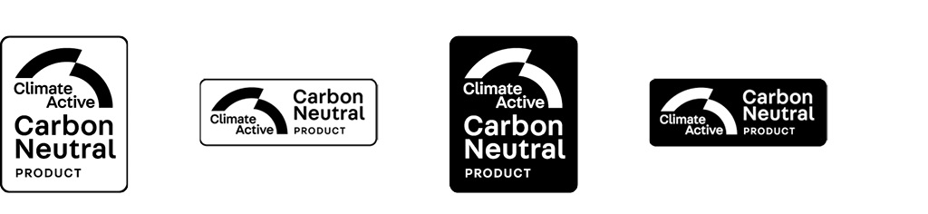

White Versions

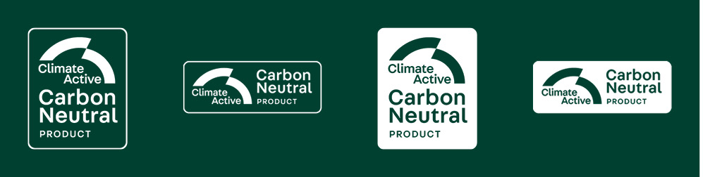

2.5. Clear space

When displaying the Certification Trade Mark or its variants on any materials, the Approved User must ensure that no other graphic, text or colour encroaches on the minimum amount of clear space required to border the Certification Trade Mark as set out below.

An exception to this rule is when using the ‘White Version’ of the Certification Trade Mark and its variants as set out above, which may only be used over midtone or dark colours to ensure their legibility.

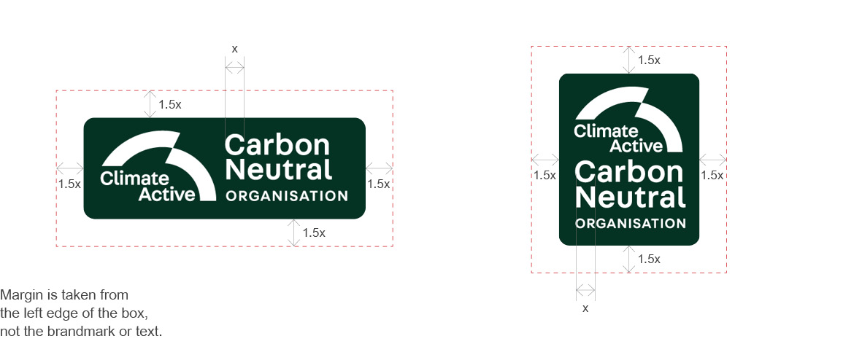

2.6. Minimum size

The Certification Trade Mark and its variations may not be displayed in sizes smaller than as set out below:

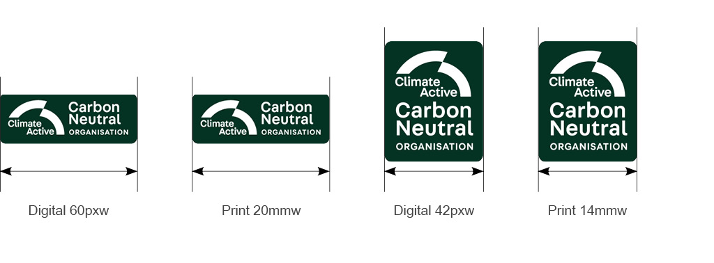

2.7. Certification Trade Mark do’s and don’ts

**Do's** The Certification mark should only be used in the correct colours, format and variations. Only use supplied master artwork files when creating artwork and adhere to the specified guidelines within this document.

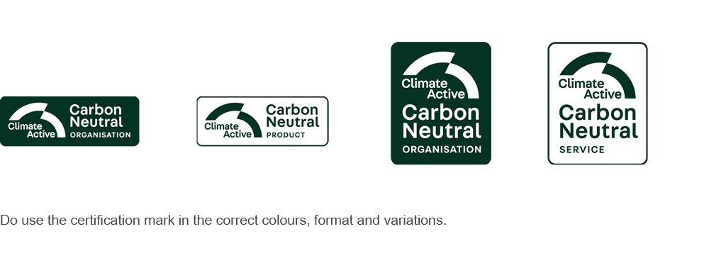

**Don'ts** Don't alter Certification mark or its variants in any way other than provided in this User Guide.

