
PUBLIC
DISCLOSURE STATEMENT
GTA Industrial Custodian Pty Limited as Trustee of Redbank River Park Industrial Trust product
Redbank Motorway Estate – CHEP
CERTIFICATION (as built)

Australian Government
Climate Active
Public Disclosure Statement



NAME OF CERTIFIED ENTITY | GTA Industrial Custodian Pty Limited as Trustee of Redbank River Park Industrial Trust for Redbank Motorway Estate - CHEP, 70 Weedman Street, Redbank, QLD -4310
REPORT TYPE/ PERIOD | 28 April 2025  As built certification
DECLARATION | To the best of my knowledge, the information provided in this public disclosure statement is true and correct and meets the requirements  of the Climate Active Carbon Neutral Standard.  Emma McMahon
DECLARATION | Emma McMahon  General Manager- Sustainability, Australia  28 April 2025

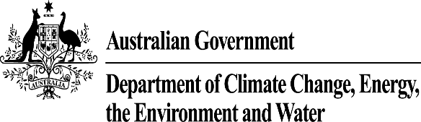

Public Disclosure Statement documents are prepared by the submitting organisation. The material in Public Disclosure Statement documents represents the views of the organisation and do not necessarily reflect the views of the Commonwealth. The Commonwealth does not guarantee the accuracy of the contents of the Public Disclosure Statement documents and disclaims liability for any loss arising from the use of the document for any purpose.

1. Certification summary
TOTAL EMISSIONS OFFSET | 5,854 tCO2-e
THE OFFSETS USED | 45% ACCUs  55% VCUs
RENEWABLE ELECTRICITY | 0%
CARBON ACCOUNT | Prepared by: Goodman Property Services (Aus)  Oct 2024
TECHNICAL ASSESSMENT | Completed  24/02/2025  LCI Consultants
THIRD PARTY VALIDATION | Completed  24/02/2025  LCI Consultants

Contents
1. Certification summary 3
2. Certification information 5
3. Emissions boundary 6
4. Emissions reductions 10
5. Emissions summary 11
6. Carbon offsets 13
7. Renewable Energy Certificate (REC) summary 16
Appendix A: Additional information 17
Appendix B: Electricity summary 18
Appendix C: Inside emissions boundary 19
Appendix D: Outside emission boundary 20

2. Certification information

Description of product certification
This is an upfront carbon certification for Redbank Motorway Estate – CHEP, constructed at 70 Weedman Street, Redbank, QLD 4310, and has been completed in accordance with the Climate Active Products and Services Standard and the Climate Active Guideline: Upfront Carbon for Buildings, 2024.
Redbank Motorway Estate – CHEP is a new warehouse that begun construction in November 2022 and achieved Practical Completion in November 2023.
The development covers an area of 33,208 m², and includes the following areas:
- Warehouse Area - 7,289 m²
- Office Area - 416 m²
- Hardstand Area - 26,147 m²
- Awning - 1,793 m²
The Gross Floor Area (GFA) of the development is 8,163 m².
The functional unit for the project is sqm of Gross Floor Area (GFA) of constructed building. The emissions intensity (emissions per functional unit) for this development is 0.717 tonnes CO₂-e/m².
Building Upfront Carbon provides coverage for all construction emissions treating the completed building as the product and the emissions boundary encompassing cradle to gate, where the gate is the delivery of the completed base building.
The carbon inventory includes emissions calculated for stages A1 – A5 of the base building. The emissions boundary excludes A0 emissions.
The project has been designed in line with Green Star Design & As Built v1.3.
The responsible entity for this certification is GTA Industrial Custodian Pty Limited as Trustee of Redbank River Park Industrial Trust (ABN: 45 081 823 743), which is part of the Goodman Group.

3. Emissions boundary

Inside the emissions boundary
The emissions boundary includes product stages A1 to A5 as per EN15804.
Quantified emissions have been deemed as ‘attributable processes’ that become the product or service, make the product or service, and carry the product or service through its life cycle. These have been quantified in the carbon inventory.
Non-quantified emissions have been deemed as attributable and are captured within the emissions boundary but are not measured (quantified) in the carbon inventory. All material emissions are accounted for through an uplift factor. Further detail is available at Appendix C.

Outside the emissions boundary
Non-attributable emissions have been deemed as not attributable to a product or service. They can be listed as outside of the emissions boundary (and are therefore not part of the carbon neutral claim). Further detail is available at Appendix D.

Quantified
Embodied emissions in construction materials incorporated into the structure (A1-3)
Embodied emissions in materials used during construction (for example: permanent formwork)
Transport of materials to the construction site (A4)
Construction energy (A5):
Electricity
Diesel
Petroleum
Construction waste (A5)
Non-quantified
Materials, such as bathroom fixers and kitchen cabinets were non quantified based on immateriality. These sources combined equal less than 5% of the carbon account.
Outside emission boundary
Non-attributable
Tenancy fitout
Base building operations (B6)
Tenancy operations (B6)
Building refurbishment or maintenance during operational lifetime (B1-7)
Demolition at end of life (C1-4)

Inside emissions boundary

Product process diagram
Cradle-to-gate where achievement of practical completion of the project marks the “gate”, lifecycle stages A1 to A5 as per EN15978.

Raw material extraction & supply
A1
Transport to manufacturing plant
A2
Manufacturing & fabrication
A3
Transport to project site
A4
Construction & installation process
A5
Delivery phase
Pre construction
A0

- A1 Raw material extraction and supply
- A2 Transport to manufacturing plant
Excluded emission sources
N/a
Upstream
emissions
Production/Service delivery
Downstream
emissions
- A3 Manufacturing and fabrication
- A4 Transport to construction site
- A5 Construction and installation processes
- Treatment and transportation of Waste generated during construction

4. Emissions reductions

Emissions reduction strategy
The design of Redbank Motorway Estate - CHEP has been guided by the objective to minimise building lifecycle emissions recognising that decisions made to manage upfront emissions can influence operational emissions.
The upfront emissions reductions strategies include:
- Dematerialistion by optimising structural and façade elements
- Prioritising;
  - lower carbon emissions materials
  - Renewable materials
  - Recycled materials
  - Materials recognised by third party certification schemes and independent verification methods e.g. Environmental product declarations (EPDs)
- Applying a project cost of carbon to provide a fair comparison of materials with varying carbon intensity
- Modularising elements of construction to reduce waste and transport emissions
- Local procurement of steel and concrete materials, where possible
- Project diverted >90% waste from landfill
The operational emissions reductions include;
• Designed in line with a 5 star Green Star Design & As Built rating v1.3;
• Office designed in line with 5 star NABERS Energy requirements;
• Reduced HVAC and HWS operational energy consumption;
• Installation of 450 kW rooftop solar PV system and 4 EV charging points
• Water efficient tap fittings to reduce leaks;
• Landscape irrigation with smart meters installed to reduce consumption;
• Rainwater and GPT installed to recycle water; and
• LED lights with motion sensors installed to reduce electricity consumption

5. Emissions summary

Climate Active carbon neutral products and services
The use of Climate Active carbon neutral products and services is included in the carbon account as 0 emissions.
Certified brand name | Product or Service used
 | N/A

Emissions Summary Table
This certification is for a completed development with emissions calculated from product specific emission intensity information for construction materials using As-Built drawings and site plans. Emissions from electricity use and fuels used on the construction site have been modelled using hours of operation of different equipment used during construction with the emission factors embedded in e-Tool.
The functional unit for the project is sqm of Gross Floor Area (GFA) of constructed building. The emissions intensity (emissions per functional unit) for this development is 0.717 tonnes CO_{2-e}/m².
Material | As-built t CO₂-e
Hardstand | 1,975
Floors | 1,078
Retaining Wall | 55
Footings | 81
Precast Walls | 279
External Walls | 172
Roof | 540
Columns & Walls | 694
Solar | 553
Others | 427
TOTAL t CO₂-e | 5,853.3
No uplift factors were added in the emissions total.
Emissions intensity per functional unit | 0.717
Number of functional units offset | 8,163
Total emissions offset | = 0.717 * 8,163  = 5,854 tCO2e

6. Carbon offsets

Offsets retirement approach
In addition to the Climate Active requirements for offsets, the following criteria have been considered in the selection of carbon credits purchased for this project:
- Nature-based solutions projects (reforestation, afforestation, and improved forest management)
- All units must have a vintage year later than 2016
- 45% of all projects are Australian Carbon Credit Units (ACCUs), issued by the Clean Energy Regulator
- International offsets to include the following;
  - Certified Emissions Reductions (CERs), issued as per the rules of the Kyoto Protocol from Clean Development Mechanism projects
  - Removal Units (RMUs) issued by a Kyoto Protocol country based on land use, land-use change and forestry activities under Article 3.3 or Article 3.4 of the Kyoto Protocol
  - Verified Emissions Reductions (VERs) issued by the Gold Standard
  - Verified Carbon Units (VCUs) issued by the Verified Carbon Standard.
Carbon Conscious Carbon Capture Project, Western Australia
Registered in 2014, this project establishes permanent plantings of mallee eucalypt tree species on land that was predominantly used for agricultural purposes for at least five years prior to project commencement. The project area spans several properties across Western Australia.
Katingan Peatland Restoration and Conservation Project, Indonesia
The Katingan Peatland Restoration and Conservation Project seeks to protect and restore 149,800 hectares of peatland ecosystems, to offer local people sustainable sources of income, and to tackle global climate change. The project is located in the Central Kalimantan region of Indonesia, and is aimed at reducing and avoiding emissions related to Planned Deforestation and Reforestation in combination with Conservation of Undrained and Partially drained Peatlandand Rewetting of Drained Peatland activities.
The ecologically significant tropical peatlands within the project area store approximately 20 times more carbon below ground than in above-ground vegetation, highlighting their important role as a carbon sink. The Katingan Mentaya REDD project finances the conservation of these peatlands by appropriately valuing the natural capital and the ecosystem services they provide, preventing significant volumes of carbon dioxide from being released into the atmosphere.

Practical completion
- Total emissions footprint to offset for this report | = 5,854 tonnes CO2-e
- Total offsets retired in design (commitment) PDS | = 0
- Total offsets required for this report | = 5,854 tonnes CO2-e

Co-benefits
Carbon Conscious Carbon Capture Project
- This Environmental Plantings project involves 5,700 hectares of reforestation, contained on 14 properties within the Central and Northern Agricultural Regions of Western Australia.
- From 2009 to 2010, over 6,000,000 native species mallee trees were planted on land previously cleared for dryland cropping and grazing, to reforest the area, with a permanence period of at least 100 years.
Katingan Peatland Restoration and Conservation Project
- In partnership with 34 local villages, the project aligns with sustainable development initiatives by building community capacity, increasing employment and education.
- By fostering inclusive partnerships and a culture of nature-connection and sustainability in local communities, the project serves to reduce poverty, enhance the well-being of communities, and reorient deforestation trends and their destructive environmental and climate impacts.

Eligible offsets retirement summary
Offsets retired for Climate Active Carbon Neutral Certification
Project description | Type of offset units | Registry | Date retired | Serial number (and hyperlink to registry transaction record) | Vintage | Stapled quantity | Eligible quantity used for commitment reporting (if applicable) | Eligible quantity used for final as-built reporting | Percentage of total (%)
Carbon Conscious Carbon Capture Project 1 | ACCU | ANREU | 11 April 2025 | 8,338,108,810 -8,338,111,443 | 2022 | 0 | 0 | 2,634 | 45%
Katingan Peatland Restoration and Conservation Project | VCU | VERRA | 11 April 2025 | 12730-429901608-429904827-VCS-VCU-263-VER-ID-14-1477-01012020-31122020-0 | 2020 | 0 | 0 | 3,220 | 55%
 | Total offsets retired this report and used in this report |  |  |  |  |  |  | 5,854 | 100%
Total offsets retired previously for commitment reporting (if applicable) |  |  |  |  |  |  | N/A

Type of offset units | Eligible quantity used for commitment reporting (if applicable) | Eligible quantity used for final as-built reporting | Total eligible quantity used for commitment and final-as built reporting | Percentage of total
Australian Carbon Credit Units (ACCUs) | 0 | 2,634 | 2,634 | 45%
Verified Carbon Units (VCUs) | 0 | 3,220 | 3,220 | 55%

7. Renewable Energy Certificate (REC) summary

Renewable Energy Certificate (REC) Summary
N/A

Appendix A: Additional information
The retirement certificate for purchased Carbon credit projects are provided below.
45% Australian Carbon Credit Unit (ACCUS):
- Carbon Conscious Carbon Capture Project 1
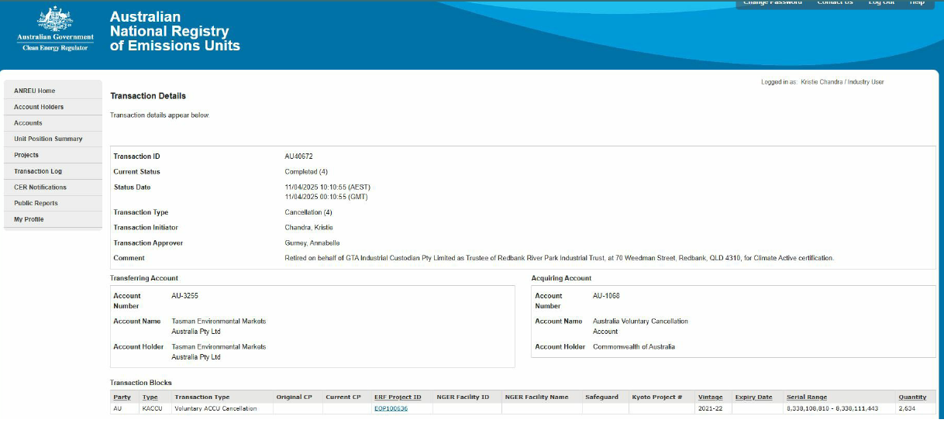
55% Verified Carbon Units (VCUs)
- Katingan Peatland Restoration and Conservation Project
Verra Registry
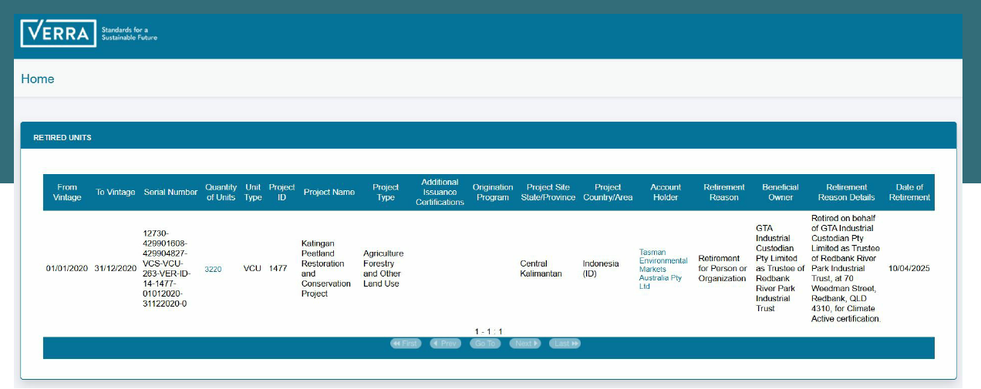

Appendix B: Electricity summary
Not applicable as electricity is calculated through Etool LCA software.

Appendix C: Inside emissions boundary
Emissions as described earlier within the boundary of phases A1 to A5 of the building construction project. Materials, such as bathroom fixers and kitchen cabinets were non quantified based on immateriality

Non-quantified emissions sources
The following emissions sources have been assessed as attributable, are captured within the emissions boundary, but are not measured (quantified) in the carbon inventory. These emissions are accounted for through an uplift factor. They have been non-quantified due to one of the following reasons:
- Immaterial <1% for individual items and no more than 5% collectively
- Cost effective Quantification is not cost effective relative to the size of the emission but uplift applied.
- Data unavailable Data is unavailable, but uplift applied. A data management plan must be put in place to collect data prior to the as-built report.
Please advise which of the reasons applies to each of your non-quantified emissions. You may add rows if required.
Relevant non-quantified emission sources | Justification reason
Bathroom fixers | Immaterial
Kitchen cabinets | Immaterial

Excluded emissions sources
Attributable emissions sources can be excluded from the carbon inventory, but still considered as part of the emissions boundary if they meet all three of the below criteria. An uplift factor may not necessarily be applied.
- A data gap exists because primary or secondary data cannot be collected (no actual data).
- Extrapolated and proxy data cannot be determined to fill the data gap (no projected data).
- An estimation determines the emissions from the process to be immaterial.
 | No actual data | No projected data | Immaterial
NA | NA | NA | NA
NA | NA | NA | NA

Data Management Plan
There are no non-quantified sources in the emission boundary that require a data management plan.

Appendix D: Outside emission boundary
Emissions associated with future management of the building and use of the building by future occupants are excluded since they are non-attributable, outside of the emissions boundary. This as-built certification is for the design phase of a carbon neutral building product. The emissions boundary is based on the lifecycle stages A1 to A5 as per EN15978.



Emissions are shown for each material and include emissions across the 5 lifecycle stages.

