
PUBLIC
DISCLOSURE STATEMENT

Four Pillars gin
product CERTIFICATION
CY2024

Australian Government
Climate Active
Public Disclosure Statement


NAME OF CERTIFIED ENTITY | Four Pillars
REPORTING PERIOD | 1 January 2024 – 31 December 2024 [Arrears Report]
DECLARATION | To the best of my knowledge, the information provided in this public disclosure statement is true and correct and meets the requirements  of the Climate Active Carbon Neutral Standard.
DECLARATION | Tamara Sling-Ronen  Environment Director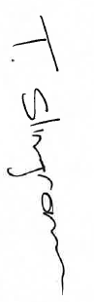  Date: 7/4/2026



Public Disclosure Statement documents are prepared by the submitting organisation. The material in Public Disclosure Statement documents represents the views of the organisation and do not necessarily reflect the views of the Commonwealth. The Commonwealth does not guarantee the accuracy of the contents of the Public Disclosure Statement documents and disclaims liability for any loss arising from the use of the document for any purpose.
Version 9.1.

Certification summary
TOTAL EMISSIONS OFFSET | 653 tCO₂-e
CARBON OFFSETS USED | 20.06% ACCUs, 79.94% CERs
RENEWABLE ELECTRICITY | 99.09%
CARBON ACCOUNT | Prepared by: Lion Pty Ltd
TECHNICAL ASSESSMENT | 30/11/2021  Paola Martinez  Ndevr Environmental  Next technical assessment due: CY2025

Contents

1. Certification summary 3
2. Certification information 4
3. Emissions boundary 6
4. Emissions reductions 9
5. Emissions summary 10
6. Carbon offsets 13
7. Renewable Energy Certificate (REC) summary 16
Appendix A: Additional information 17
Appendix B: Electricity summary 22
Appendix C: Inside emissions boundary 25
Appendix D: Outside emission boundary 26

Certification information

Description of product certification
This product certification is for every bottle of gin we make, all of it produced at our Four Pillars Distillery in Healesville. The parent certification is submitted under Lion Pty Ltd organization certificate and has a Parent-Child relationship with the Four Pillars Gin product certification. This certification captures the overlapping emissions between Lion Pty Ltd and Four Pillars Gin. Under the Climate Active technical guidance manual, the liability for the shared emissions is offset as part of the organization certificate and will be deemed carbon neutral when linked to its child certifications.
Four Pillars makes gin and only gin. In fact, the only things we make that are not gin are ‘Made From Gin’ (by-products and bottled gin cocktails).
What makes every Four Pillar Gin special is a combination of purity of spirit (we distill every gin to be the highest quality spirit) and concentration of flavour (we’re passionate about packing all the flavour possibilities of modern Australia into our gins).
Four Pillars exclusively makes modern Australian gins. That means drawing on traditional gin botanicals and finding the best botanicals in the world to work with, such as our Macedonian juniper. And it means working with the unique botanicals, produce and flavours of Australia, from native seeds, nuts and flowers to whole fresh citrus. It’s this combination that has made Four Pillars the most awarded and flavoursome family of gins on the planet.
A Cradle-to-gate approach was used as it was not initially possible to map the stages between gate to grave as this would have required us to estimate data for a product that was yet to be distributed to the market. This approach is allowed under the Product & Services standard if function of the final product is not known or there are significant barriers to collecting data.
- Functional unit: 1 Litre of Four Pillars Gin Produced
- Offered as: full coverage product
- Life cycle: cradle-to-gate
The responsible entity for this product certification is Healesville Distilling Pty Ltd, ABN 89 606 461 367.
This Public Disclosure Statement includes information for CY2024 reporting period.

Description of business
Four Pillars Gin is a gin producer based in the Yarra Valley, an hour from the centre of Melbourne. At our home, Four Pillars Distillery in Healesville, we’re focused single-minded on exploring the delicious possibilities of distilling gin in Australia. We believe Australia is the most delicious place on earth, and we’re committed to capturing the flavours of Australia in the world’s most creative, drinkable and awarded family of gins.
Four Pillars exclusively uses copper stills made by CARL of Germany. Every day our production stills (Wilma, Jude, Beth and Linda) are distilling Rare Dry Gin (our signature gin made with classic gin botanicals plus native Australian lemon myrtle, Tasmanian pepperberry and whole fresh oranges). In addition to our Rare Dry Gin, the heart and soul of our business, Four Pillars makes Olive Leaf Gin (made for a perfect Martini), Spiced Negroni Gin (the world’s first dedicated Negroni gin), Navy Strength Gin (the world’s most awarded overproof gin), Bloody Shiraz Gin (an iconic one of a kind) plus a whole family of limited edition, collaborative and barrel-aged gins.
As passionate explorers of gin and flavour, Four Pillars also makes a delicious family of gin-fuelled by-products, our Made From Gin family. Marmalade, chocolate, Ricci’s Bikkies and salt are just some of the products made using gin-steamed oranges and spent gin botanicals. And it’s this commitment to craft, creativity, sustainability and (above all) gin that is the signature of Four Pillars.
In addition to our home in Healesville, Four Pillars operates a drinks-led Laboratory in Sydney’s Surry Hills and is widely available across Australia and around the world. Four Pillars has been named International Gin Producer of the Year three times at the International Wine & Spirits Competition (IWSC) in London (2019, 2020 & 2023). In September 2022 Four Pillars won the IWSC Inaugural Green Spirit Trophy and in 2024 Sustainability Officer of the year at the World Gin Awards.
Lion took full ownership of Four Pillars in 2023. The acquisition includes ownership of the Healesville distillery and all domestic and international sales and marketing of the brand.

Emissions boundary

Inside the emissions boundary
All emission sources listed in the emissions boundary are part of the carbon neutral claim.
Quantified emissions have been assessed as ‘attributable processes’ of a product or service. These attributable processes are services, materials and energy flows that become the product or service, make the product or service and carry the product or service through its life cycle. These attributable emissions have been quantified in the carbon inventory.
Non-quantified emissions have been assessed as attributable and are captured within the emissions boundary, but are not measured (quantified) in the carbon inventory. All material emissions are accounted for through an uplift factor. Further detail is available at Appendix C.

Outside the emissions boundary
Non-attributable emissions have been assessed as not attributable to a product or service. They can be optionally included in the emissions boundary and therefore have been offset, or they can be listed as outside of the emissions boundary (and are therefore not part of the carbon neutral claim). Further detail is available at Appendix D.

Quantified
Electricity
Natural gas
Water
Wastewater
Raw materials:
- Neutral grain spirit
- Botanicals
Packaging
Freight and Transport
Waste:
- Recycling
- General

Non-quantified
None

Outside emission boundary
Non-attributable
N/A
Optionally included
None

Inside emissions boundary

Product process diagram

Cradle-to-gate boundary
Raw material Purchasing
- Raw material sourcing, including:
  - Grain spirit
  - Botanicals
Excluded emission sources
N/A
Upstream
emissions
Production
Downstream
emissions
Upstream Transport
- Transport of raw materials to manufacturing plant
- Transport of packaging items
Manufacturing
- Electricity
- Natural gas
- Water
- Wastewater
- Waste
Bottling
- Packaging
  - Glass bottles
  - Screw caps
  - corks
  - Capsules (sleeves)
  - Labels
Downstream transport & storage
- Transport of final product to warehouse for sale
- Electricity used in storage space

Emissions reductions

Emissions reduction strategy
As a subsidiary of Lion Pty Ltd, Four Pillars is aligned to the sustainability targets Lion has committed to. In line with science-based targets to limit global warming to under 1.5°C, Lion has committed to a 55% reduction of Scope 1 and 2 emissions from a 2019 baseline by 2030. As part of this strategy, Lion has committed to using 100% renewable electricity across sites, including Four Pillars, in the Australian and New Zealand network by 2025. In addition to direct carbon reductions, Lion recognises the necessity of carbon reductions in the value chain and has set a science-based target to reduce Scope 3 emissions by 30% by 2030, as compared to 2019 baselines.
Four Pillars is committed to reducing our emissions and dedicated to achieving broader sustainability wins that will reduce our impact on our environment. Throughout 2024, Four Pillars have worked with manufacturing and packaging suppliers to meet Lion Australia’s supplier compliance requirements. They have provided information on their product’s quality, food safety, cyber security, sustainability, and their company’s policies on modern slavery and inclusion and diversity. Four Pillars is in alignment with Lion Australia’s internal policies including Modern Slavery, Inclusion and Diversity, Environment policy, Anti-bribery, Wellbeing and Health and Safety.
With packaging accounting for 50% of Four Pillars Gin product emissions, rethinking the iconic bottle became a critical focus of the sustainability strategy. Four Pillars continues to work on reducing the glass weight, increasing the recycled content of the bottle, simplification of the closures used, sourcing optimisation to reduce emissions from freight and updating bottle labels.

Emissions reduction actions
In the last year, the Four Pillars team worked on the following initiatives to reduce carbon emissions and contribute to a circular economy:
- Installed 2 new electric vehicle charging stations in our carpark
- Cap suppliers packaging changed to recyclable plastic, reducing amount of plastic sent to landfill
- Introduced Biogone sustainable materials for all carton tape and pallet wrap.
- Replaced thick carton dividers with slimline versions, reducing weight by over 70%.
- Continued 100% Purchased renewable electricity at the Healesville distillery and warehouse sites achieved through Lion’s power purchasing agreement

Emissions summary

Emissions over time
Emissions since base year
 |  | Total tCO₂-e | Emissions intensity of the functional unit
Base year (not certified): | 2021 | 2,156 | 0.00289
Year 1: | 2022 | 2,528 | 0.00291
Year 2: | 2023 | 2,294 | 0.00295
Year 3: | 2024 | 681 | Confidential

Significant changes in emissions
Emissions have decreased vs 2023 due to decrease in production volume which was driven by a reduction in demand in gin category, change customer spending patterns and cost of living pressure.
Significant changes in emissions
Attributable process | Previous year emissions  (t CO₂-e) | Current year emissions  (t CO₂-e) | Reason for change
Ethanol from wheat | 655.93 | 168.00 | Driven by a reduction in production volume
Glass Packaging | 670.03 | 225.23 | Driven by a reduction in production volume
Metal Products | 434.90 | 138.52 | Driven by a reduction in production volume

Use of Climate Active carbon neutral products, services, buildings or precincts
Certified brand name | Product/Service/Building/Precinct used
N/A | N/A

Emissions summary

Life cycle stage | tCO₂-e
Bottling | 396.7
Raw Material Purchasing | 174.3
Manufacturing | 31.4
Upstream Transport | 69.4
Downstream Transport & Storage | 8.6
Attributable emissions (tCO₂-e) | 680.5

Life cycle stage | Shared Emissions between Parent-Child tCO₂-e
Bottling | 0.0
Raw Material Purchasing | 0.0
Manufacturing | 27.9
Upstream Transport | 0.0
Downstream Transport & Storage | 0.0
Attributable emissions (tCO₂-e) | 27.9

Product offset liability
Emissions intensity per functional unit (1 Litre of Four Pillars Gin Produced) | Confidential
Emissions intensity per functional unit including uplift factors | N/A
Number of functional units covered by the certification | Confidential
Total emissions covered in the Four Pillars Gin Product Certification | 680.5
Total emissions shared between Lion Pty Ltd Organisation Certification and Four Pillars Gin Certification | 27.9
Total emissions (tCO₂-e) to be offset | 652.6

Carbon offsets

Eligible offsets retirement summary
Offsets retired for Climate Active certification
The total emissions shared between Lion Pty Ltd Organisation Certification and Four Pillars Gin Product Certification is 28t CO₂-e and has been offset in the parent certification.
Type of offset unit | Quantity used for this reporting period | Percentage of total units used
Australian Carbon Credit Units (ACCUs) | 131 | 20.06%
Certified Emissions Reductions (CERs) | 522 | 79.94%

Project name | Type of offset unit | Registry | Date retired | Serial number | Vintage | Total quantity retired | Quantity used in previous reporting periods | Quantity banked for future reporting periods | Quantity used for this reporting period | Percentage of total used this reporting period
Central Arnhem Land Fire Abatement (CALFA) Project | ACCU | ANREU | 22/09/2021 | 3,800,745,123 – 3,800,746,482 | 2019-20 | 1,360 | 1065 | 164 | 131 | 20.06%
Colac Beltram Munberry Haredean (CBMH) Regeneration Project | ACCU | ANREU | 3/05/2022 | 3,807,543,262 - 3,807,543,636 | 2020-21 | 375 | 0 | 375 | 0 | 0.00%
South East Arnhem Land Fire Abatement Project (SEALFA) Project | ACCU | ANREU | 3/05/2022 | 8,329,088,333 - 8,329,088,432 | 2020-21 | 100 | 0 | 100 | 0 | 0.00%
Bundled Wind Power Project in Tamil Nadu, India, co-ordinated by Tamil Nadu Spinning Mills Association (TASMA-II) | CER | ANREU | 3/05/2022 | 223,447,926 - 223,449,350 | CP2 | 1,425 | 1425 | 0 | 0 | 0.00%
Barcheka Regeneration project | ACCU | ANREU | 21/12/2021 | 3,805,703,330 - 3,805,703,829 | 2020-21 | 500 | 0 | 500 | 0 | 0.00%
Wongalee Mervyndale and Rundalua Forest Regeneration Project | ACCU | ANREU | 21/12/2021 | 3,803,450,882 - 3,803,451,181 | 2020-21 | 300 | 0 | 300 | 0 | 0.00%
South East Arnhem Land Fire Abatement Project (SEALFA) Project | ACCU | ANREU | 21/12/2021 | 8,329,069,985 - 8,329,070,284 | 2020-21 | 300 | 0 | 300 | 0 | 0.00%
Grid Connected Wind Energy Generation at Andhra Pradesh | CER | ANREU | 21/12/2021 | 265,611,809 - 265,615,108 | 2020-21 | 3,300 | 351 | 2427 | 522 | 79.94%
Offset Totals: |  |  |  |  |  | 7660 | 2841 | 4166 | 653 | 100.00%

Co-benefits

- Project Type: Human-Induced regeneration of native forests

This project type stores carbon by regenerating native forests. Additional benefits from these projects can include improved quality of rural land and water supply, increased biodiversity and shade and shelter for farmed livestock.

- Project Type: Winds of change

The Winds of change projects introduce clean energy to the grid in India which would otherwise be generated with coal-fired power. This project type improves the electricity availability in the rural area and reduces occurrence of blackouts. New roads were built during the construction of the turbines, improving accessibility for the locals. Improved employment opportunities was also a co-benefit with local employment as engineers, maintenance technicians, operators and security guards which boosts the local economy and village services.

7. Renewable Energy Certificate (REC) summary

Renewable Energy Certificate (REC) Summary
The following RECs have been surrendered to reduce electricity emissions under the market-based reporting method. The 340 LGCs listed in the table is the proportion of LGCs surrendered to cover the electricity emissions from the production and storage of the Four Pillars Gin product at the Healesville distillery and warehouse. The LGCs below have been surrendered and form part of the LGCs surrendered in the Lion Pty Ltd organisation certification. Lion Pty Ltd PDS for the CY2024 reporting period can be found in https://www.climateactive.org.au/buy-climate-active/certified-members/lion.
- Large-scale Generation certificates (LGCs)* | 340

* LGCs in this table only include those surrendered voluntarily (including through PPA arrangements), and does not include those surrendered in relation to the LRET, GreenPower, and jurisdictional renewables. The LGCs stated in this summary were derived from the Healesville distillery and warehouse electricity consumption attributed to the production of Four Pillars Gin relative to the total electricity consumed at the site.

Details of the LGCs surrendered that cover the electricity for Lion organisation including manufacturing of the Four Pillars Gin product are covered in the Lion organisation certification.

Appendix A: Additional information
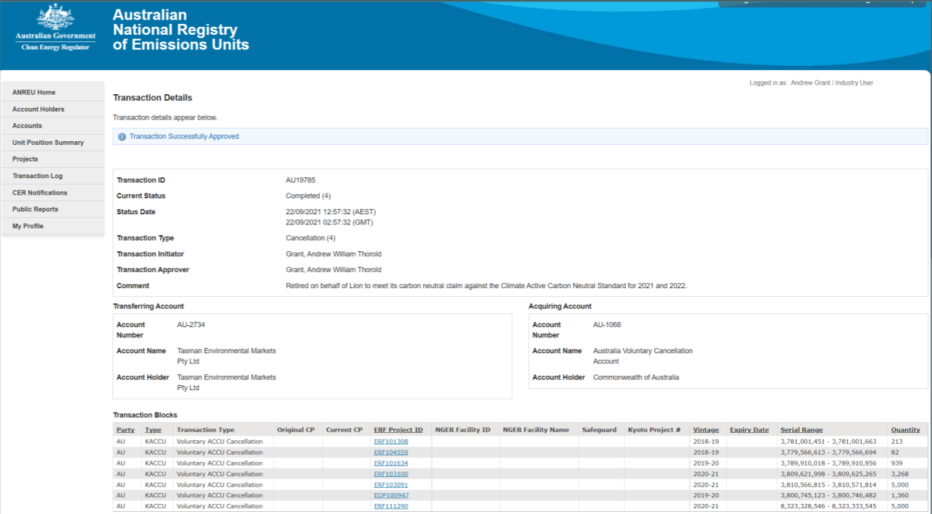
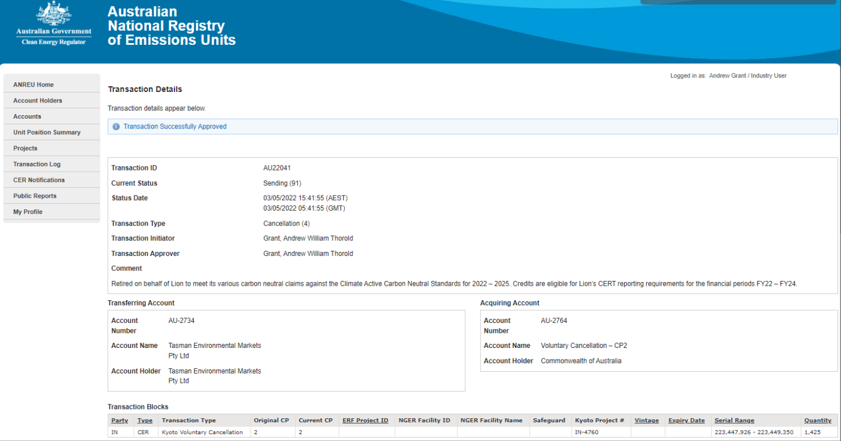
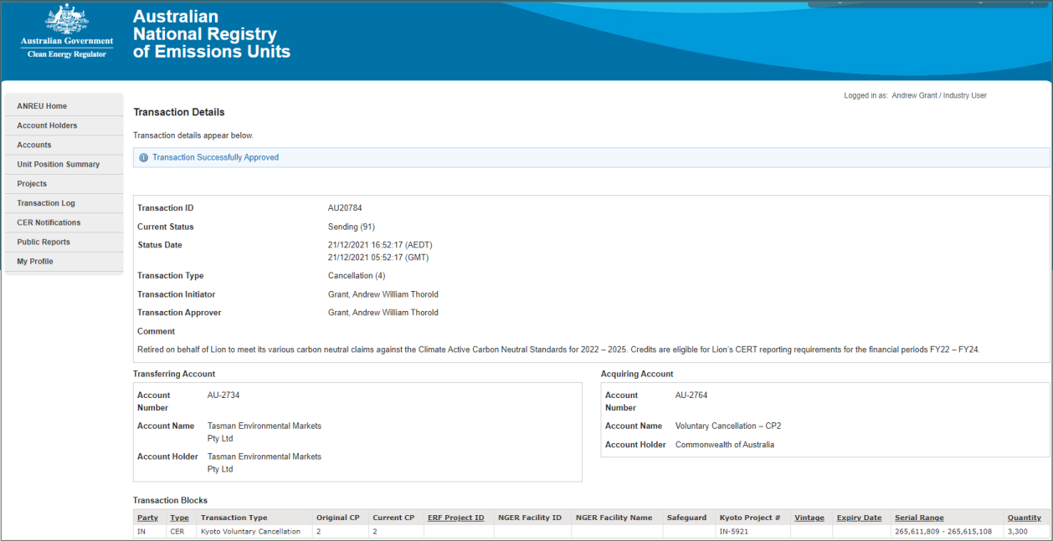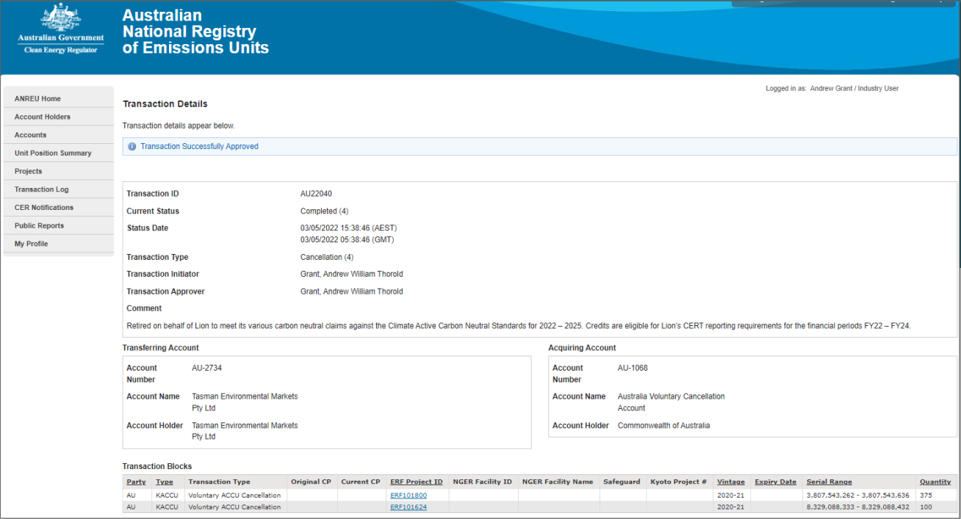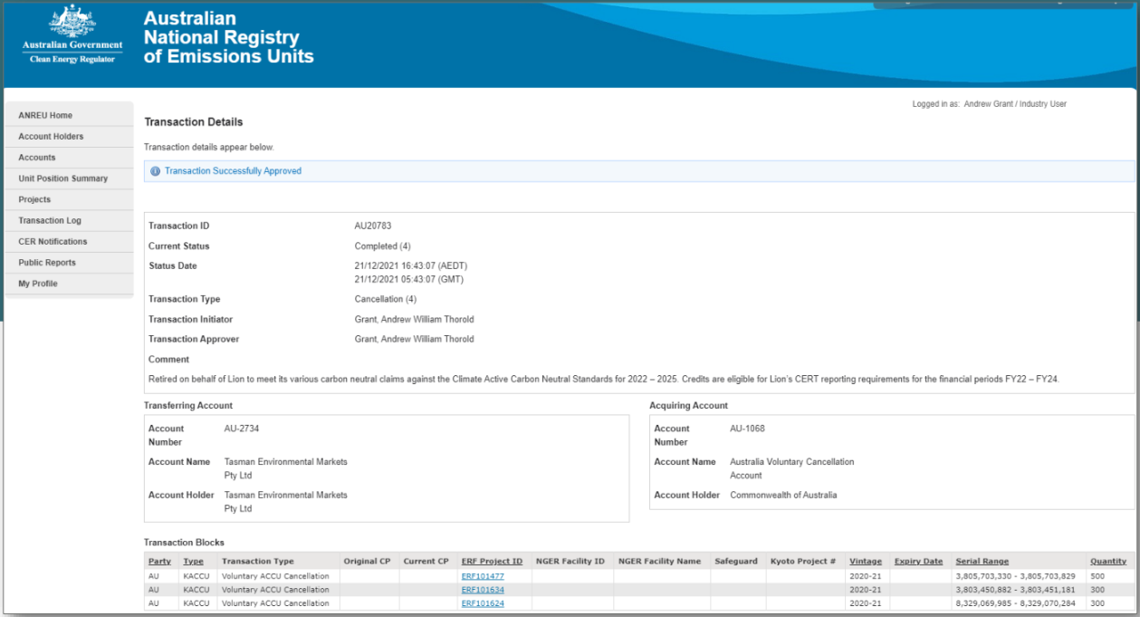

Appendix B: Electricity summary
There are two international best-practice methods for calculating electricity emissions – the location-based method and the market-based method. Reporting electricity emissions under both methods is called dual reporting.
Dual reporting of electricity emissions is useful, as it provides different perspectives of the emissions associated with a business’s electricity usage.
Location-based method
The location-based method provides a picture of a business’s electricity emissions in the context of its location, and the emissions intensity of the electricity grid it relies on. It reflects the average emissions intensity of the electricity grid in the location (State) in which energy consumption occurs. The location-based method does not allow for any claims of renewable electricity from grid-imported electricity usage.
Market-based method
The market-based method provides a picture of a business’s electricity emissions in the context of its renewable energy investments. It reflects the emissions intensity of different electricity products, markets and investments. It uses a residual mix factor (RMF) to allow for unique claims on the zero emissions attribute of renewables without double-counting.
For this certification, electricity emissions have been set by using the market-based approach.

The electricity covered in the Four Pillars Gin product certification comes from 2 sources: electricity from production and storage of the Four Pillars Gin product and electricity from downstream transport and wholesale storage which includes storage at the Four Pillars Healesville warehouse. As the Lion organisation certification is the parent inventory, 340 LGCs have been specified to cover the emissions that were attributed to the production and storage of Four Pillars Gin at the Healesville distillery and warehouse. The residual emissions are then attributed to the downstream transport and wholesale storage which are not in the Lion organisation certification.
Market-based approach summary
Market-based approach | Activity Data (kWh) | Emissions  (kgCO₂-e) | Renewable percentage of total
Behind the meter consumption of electricity generated | 129,680 | 0 | 23%
Total non-grid electricity | 129,680 | 0 | 23%
LGC Purchased and retired (kWh) (including PPAs) | 340,000 | 0 | 61%
GreenPower | 0 | 0 | 0%
Climate Active precinct/building (voluntary renewables) | 0 | 0 | 0%
Precinct/Building (LRET) | 0 | 0 | 0%
Precinct/Building jurisdictional renewables (LGCS surrendered) | 0 | 0 | 0%
Electricity products (voluntary renewables) | 0 | 0 | 0%
Electricity products (LRET) | 0 | 0 | 0%
Electricity products jurisdictional renewables (LGCs surrendered) | 0 | 0 | 0%
Jurisdictional renewables (LGCs surrendered) | 0 | 0 | 0%
Jurisdictional renewables (LRET) (applied to ACT grid electricity) | 0 | 0 | 0%
Large Scale Renewable Energy Target (applied to grid electricity only) | 78,212 | 0 | 14%
Residual Electricity | 5,014 | 4,563 | 0%
Total renewable electricity (grid + non grid) | 547,892 | 0 | 99%
Total grid electricity | 423,226 | 4,563 | 76%
Total electricity (grid + non grid) | 552,906 | 4,563 | 99%
Percentage of residual electricity consumption under operational control | 100%
Residual electricity consumption under operational control | 5,014 | 4,563
Scope 2 | 4,463 | 4,061
Scope 3 (includes T&D emissions from consumption under operational control) | 551 | 501
Residual electricity consumption not under operational control | 0 | 0
Scope 3 | 0 | 0

Total renewables (grid and non-grid) | 99.09%
Mandatory | 14.15%
Voluntary | 61.49%
Behind the meter | 23.45%
Residual scope 2 emissions (t CO₂-e) | 4.06
Residual scope 3 emissions (t CO₂-e) | 0.50
Scope 2 emissions liability (adjusted for already offset carbon neutral electricity) (t CO₂-e) | 4.06
Scope 3 emissions liability (adjusted for already offset carbon neutral electricity) (t CO₂-e) | 0.50
Total emissions liability (t CO₂-e) | 4.56
Figures may not sum due to rounding. Renewable percentage can be above 100%

Location-based approach summary
Location-based approach | Activity Data (kWh) total | Under operational control |  |  | Not under operational control
Percentage of grid electricity consumption under operational control | 100% | (kWh) | Scope 2 Emissions (kg CO₂-e) | Scope 3 Emissions (kg CO₂-e) | (kWh) | Scope 3 Emissions  (kgCO₂-e)
ACT | 0 | 0 | 0 | 0 | 0 | 0
NSW | 185 | 185 | 126 | 9 | 0 | 0
SA | 0 | 0 | 0 | 0 | 0 | 0
VIC | 423,041 | 423,041 | 334,203 | 29,613 | 0 | 0
QLD | 0 | 0 | 0 | 0 | 0 | 0
NT | 0 | 0 | 0 | 0 | 0 | 0
WA | 0 | 0 | 0 | 0 | 0 | 0
TAS | 0 | 0 | 0 | 0 | 0 | 0
Grid electricity (scope 2 and 3) | 423,226 | 423,226 | 334,328 | 29,622 | 0 | 0
ACT | 0 | 0 | 0 | 0
NSW | 0 | 0 | 0 | 0
SA | 0 | 0 | 0 | 0
VIC | 129,680 | 129,680 | 0 | 0
QLD | 0 | 0 | 0 | 0
NT | 0 | 0 | 0 | 0
WA | 0 | 0 | 0 | 0
TAS | 0 | 0 | 0 | 0
Non-grid electricity (behind the meter) | 129,680 | 129,680 | 0 | 0
Total electricity (grid + non grid) | 552,906

Residual scope 2 emissions (t CO₂-e) | 334.33
Residual scope 3 emissions (t CO₂-e) | 29.62
Scope 2 emissions liability (adjusted for already offset carbon neutral electricity) (t CO₂-e) | 334.33
Scope 3 emissions liability (adjusted for already offset carbon neutral electricity) (t CO₂-e) | 29.62
Total emissions liability | 363.95

Operations in Climate Active buildings and precincts
Operations in Climate Active buildings and precincts | Electricity consumed in Climate Active certified building/precinct (kWh) | Emissions  (kg CO₂-e)
N/A | N/A | N/A
Climate Active carbon neutral electricity is not renewable electricity. These electricity emissions have been offset by another Climate Active member through their building or precinct certification. This electricity consumption is also included in the market based and location-based summary tables. Any electricity that has been sourced as renewable electricity by the building/precinct under the market-based method is outlined as such in the market based summary table.

Climate Active carbon neutral electricity products
Climate Active carbon neutral product used | Electricity claimed from Climate Active electricity products (kWh) | Emissions  (kg CO₂-e)
N/A | N/A | N/A
Climate Active carbon neutral electricity is not renewable electricity. These electricity emissions have been offset by another Climate Active member through their electricity product certification. This electricity consumption is also included in the market based and location-based summary tables. Any electricity that has been sourced as renewable electricity by the electricity product under the market-based method is outlined as such in the market based summary table.

Appendix C: Inside emissions boundary
Non-quantified emission sources
The following emissions sources have been assessed as attributable, are captured within the emissions boundary, but are not measured (quantified) in the carbon inventory. These emissions are accounted for through an uplift factor. They have been non-quantified due to one of the following reasons:
- Immaterial <1% for individual items and no more than 5% collectively
- Cost effective Quantification is not cost effective relative to the size of the emission but uplift applied.
- Data unavailable Data is unavailable but uplift applied. A data management plan must be put in place to provide data within 5 years.
- Maintenance Initial emissions non-quantified but repairs and replacements quantified.
Relevant non-quantified emission sources | Justification reason
N/A | N/A

Excluded emission sources
Attributable emissions sources can be excluded from the carbon inventory, but still considered as part of the emissions boundary if they meet all three of the below criteria. An uplift factor may not necessarily be applied.
- A data gap exists because primary or secondary data cannot be collected (no actual data).
- Extrapolated and proxy data cannot be determined to fill the data gap (no projected data).
- An estimation determines the emissions from the process to be immaterial).

Emissions Source | No actual data | No projected data | Immaterial
N/A | N/A | N/A | N/A

Data management plan for non-quantified sources
There are no non-quantified sources in the emission boundary that require a data management plan.

Appendix D: Outside emission boundary
Non-attributable emissions have been assessed as not attributable to a product or service (do not carry, make or become the product/service) and are therefore not part of the carbon neutral claim. To be deemed attributable, an emission must meet two of the five relevance criteria. Emissions which only meet one condition of the relevance test can be assessed as non-attributable and therefore are outside the carbon neutral claim. Non-attributable emissions are detailed below.
- Size The emissions from a particular source are likely to be large relative to other attributable emissions.
- Influence The responsible entity could influence emissions reduction from a particular source.
- Risk The emissions from a particular source contribute to the responsible entity’s greenhouse gas risk exposure.
- Stakeholders The emissions from a particular source are deemed relevant by key stakeholders.
- Outsourcing The emissions are from outsourced activities that were previously undertaken by the responsible entity or from outsourced activities that are typically undertaken within the boundary for comparable products or services.

Non-attributable emissions sources summary
Emission sources tested for relevance | Size | Influence | Risk | Stakeholders | Outsourcing | Justification
N/A | N/A | N/A | N/A | N/A | N/A | N/A



