

PUBLIC
DISCLOSURE STATEMENT

lion pty ltd
Organisation CERTIFICATION

CY2024

Australian Government
Climate Active
Public Disclosure Statement


NAME OF CERTIFIED ENTITY | Lion Pty Ltd
REPORTING PERIOD | 1 January 2024 – 31 December 2024  Arrears report
DECLARATION | To the best of my knowledge, the information provided in this public disclosure statement is true and correct and meets the requirements  of the Climate Active Carbon Neutral Standard.
DECLARATION | Tamara Sling-Ronen  Environment Director  Date:



Public Disclosure Statement documents are prepared by the submitting organisation. The material in the Public Disclosure Statement document represents the views of the organisation and do not necessarily reflect the views of the Commonwealth. The Commonwealth does not guarantee the accuracy of the contents of the Public Disclosure Statement document and disclaims liability for any loss arising from the use of the document for any purpose.
Version 9.1.

Certification summary
TOTAL EMISSIONS OFFSET | 31,986 tCO₂-e
CARBON OFFSETS USED | 20% ACCUs, 80% CERs
RENEWABLE ELECTRICITY | 100%
CARBON ACCOUNT | Prepared by: Lion Pty Ltd
TECHNICAL ASSESSMENT | 21/07/2023  NDEVR Environmental Pty Ltd  Next technical assessment due: CY2025

Contents

1. Certification summary 3
2. Certification information 4
3. Emissions boundary 6
4. Emissions reductions 8
5. Emissions summary 10
6. Carbon offsets 12
7. Renewable Energy Certificate (REC) Summary 20
Appendix A: Additional Information 23
Appendix B: Electricity summary 24
Appendix C: Inside emissions boundary 28
Appendix D: Outside emissions boundary 29

Certification information

Description of organisation certification
This organisation certification is for the business operations of Lion Pty Ltd (Lion), ABN 50 128 004 268, including the subsidiaries listed in the table below.
Lion’s products are excluded from this certification. Emissions associated with the XXXX Zero and Four Pillars Gin products have their own separate certifications.
This Public Disclosure Statement includes information for CY2024 reporting period.

Organisation description
Lion is one of Australasia’s largest food and beverage companies, employing approximately 2,000 people across Australia and New Zealand. The company owns and operates various sites in Australia and New Zealand to produce beer, cider, wine, spirits, alcoholic ready-to-drink and non-alcoholic beverages. Lion premium brands are market leaders across several categories.
Our business lines are Lion Beer Australia, Lion New Zealand and Lion Little World Beverages. The certification emission boundary, however, comprehend operations in Australia only, where we manage many of the best brands in the market.
The operational control approach was used to define the emissions boundary for the organisation’s Climate Active Carbon Neutral certification. The locations included in Lion’s emissions boundary are outlined in Table 1.
The organizational reporting boundary has been revised for the current reporting period to reflect changes in Lion’s operational control. Sites that were included in the previous year’s boundary have ceased operations and are therefore excluded from this year’s scope. These sites include Byron Bay Brewing, Kosi, Four Pillars Office (Sydney), Two Birds, Canningvale Warehouse, Tiny Mountain, and West End Brewery.
The following subsidiaries are also included within this certification:
Legal entity name | ABN | ACN
Healesville Distilling Pty Ltd |  | 606 461 367
Fermentum Pty Limited |  | 124 373 324
Lion - Beer, Spirits & Wine Pty Ltd | 13 008 596 370 | 008 596 370

Table 1: Summary of sites included in the 2024 reporting boundary
Site Name | Address
Bentley Warehouse | 35 Alexandra Pl, Bentley WA 6102
Berrimah (Marine Stores) | 33 Pruen Rd, Berrimah NT 0828
Bevy | The Camfield. Roger MacKay Drive, Burswood WA 6100
Camberwell - Toorak Road | 1183 Toorak Road, Camberwell, VIC 3124
Cardiff Brewery | 18 Munibung Rd, Cardiff QLD 2285
Castlemaine Perkins Brewery | 185 Milton Rd, Milton QLD 4064
Charming Squire | Charming Squire 3/133 Grey St, South Brisbane QLD 4101
Eumundi Brewery | 1 Etheridge St, Eumundi QLD 4562
Fixation Brewing | 414 Smith Street, Collingwood, VIC
Four Pillars Gin Laboratory | 410 Crown St, Surry Hills NSW 2010
Four Pillars Healesville Distillery | 2 Lilydale Rd, Healesville VIC 3777
Four Pillars Healesville Warehouse | 15 Hunter Rd, Healesville VIC 3777
Generous Squire | 397 Murray St, Perth WA 6000
James Boag Brewery | 69 Esplanade St, Launceston TAS 7250
Little Creatures Brewery Fremantle | 40 Mews Rd, Fremantle WA 6160
Little Creatures Brewery Geelong | 221 Swanston St, South Geelong VIC 3220
Little Creatures Packaging O'Connor | 7 Jones St, O'Connor WA 6163
Lucky Squire | 3 Oracle Blvd, Broadbeach QLD 4218
Malt Shovel Brewery | 101 Pyrmont Bridge Road, Camperdown NSW 2050
Mount Waverly (Melbourne) | 1/ 7- 9 Gilby Road, Mount Waverly VIC 3149
Royal Park (Marine Stores) | 18 Wilson Street. Royal Park, SA 5014
SA Sales Office | 238 The Parade, Norwood SA
Squire's Landing | Northern end of the Overseas Passenger Terminal, Circular Quay, The Rocks NSW 2000
Stone & Wood – Byron Bay | 4 Boronia Place Byron Bay, NSW
Stone & Wood – Byron Bay Tasting Room | 100 Centennial Circuit, Byron Bay, NSW
Stone & Wood - Fortitude Valley Tasting Room | 99 Bridge Street, Fortitude Valley, QLD
Stone & Wood - Murwillumbah Brewery | 35-37 Kite Crescent, Murwillumbah, NSW
Stone & Wood - Warehouse | Units 2, 3& 4, 39-45 Kite Crescent, Murwillumbah, NSW
TAS Sales Office | Level 1, 152 Macquarie St, Hobart TAS 7000
Tooheys Brewery | 29 Nyrang St, Lidcombe NSW 2141
York St, Sydney (Lion Head Office) | 68 York St, Sydney NSW 2000

Emissions boundary

Inside the emissions boundary
All emission sources listed in the emissions boundary are part of the carbon neutral claim.
Quantified emissions have been assessed as relevant and are quantified in the carbon inventory. This may include emissions that are not identified as arising due to the operations of the certified entity, however are optionally included.
Non-quantified emissions have been assessed as relevant and are captured within the emissions boundary, but are not measured (quantified) in the carbon inventory. All material emissions are accounted for through an uplift factor. Further detail is available at Appendix C.

Outside the emissions boundary
Excluded emissions are those that have been assessed as not relevant to an organisation’s operations and are outside of its emissions boundary or are outside of the scope of the certification. These emissions are not part of the carbon neutral claim. Further detail is available at Appendix D.

Outside emission boundary
Excluded
IT Services
Event Catering
Maintenance
Purchased services
Cleaning
Consumables
Downstream emissions
Capital goods
Raw materials
Packaging materials
Use of products
Product distribution upstream & downstream
International operations
Wastewater treatment fugitive emissions

Quantified
Accommodation and facilities
Stationary energy (gaseous fuels)
Stationary energy (liquid fuels)
Transport (air)
Transport (land and sea)
Waste
Working from home

Non-quantified
N/A
Inside emissions boundary

Optionally included
N/A

Emissions reductions

Emissions reduction strategy
Championing sociability and helping people to live well is what drives us to create positive change and builds a pathway to tackle some of the biggest social and environmental challenges we collectively face.
Across our global business we’re working hard and investing to reduce our impact on the environment. Climate change has the potential to disrupt our business in many ways particularly across our supply chain. Without a drastic change in course, we can only expect more frequent and intense weather events that will cause disruptions to supply chains, increase the costs of inputs and threaten the viability of our business.
We have redefined our sustainability strategy under an Environmental, Social, Governance (ESG) framework. For us that means becoming a Force for Good by:
- Demonstrating brave and enduring environmental leadership
- Creating long term positive social impact; and
- Strengthening and safeguarding our Governance.
Under our environmental pillar, we focus on carbon reduction in our value chain, water stewardship, driving the circular economy, waste reduction and eliminating single use plastic. Goals we have committed to under this pillar include:
Our commitment to a science-based target of a 55% reduction in Scope 1 and 2 emissions and 30% reduction in Scope 3 emissions by 2030 (from a 2019 baseline).
- Scope 1 and 2: Achieve world class energy efficiency through ongoing energy optimisation leveraging best practice and new technology by 2030.
- Scope 2: Purchase 100% renewable electricity across all Australia and New Zealand sites by 2025.
In line with our parent company Kirin, Lion has also committed to a net zero value chain by 2050.

Emissions reduction actions
The key actions Lion took in 2024 to reduce emissions include:
- Continued focus on optimizing energy efficiency. Our Lion Energy and Water Champions network meets fortnightly to optimize energy efficiency at each brewery.
- On-site solar electricity generation now at five sites across our Australian network Castlemaine Brewery, Little Creatures Geelong, Healesville Distillery, Murwillumbah Brewery and Stone & Wood Tasting Room.
- Waste heat recovery
- Metering improvements
- Biogas burner improvement
- Air knife replacements with low pressure blower
- Brewing schedule optimisation
- Cleaning-in-place (CIP) optimisation
- Refrigeration chiller tuning
For further details on Lion’s emission reduction actions, please refer to our annual Sustainability report published on the Force for Good page on our corporate website: https://lionco.com/force-for-good/

Emissions summary

Emissions over time
Emissions since base year
 |  | Total tCO₂-e  (without uplift) | Total tCO₂-e  (with uplift)
Base year: | FY2018-19 | 92,901 | 92,901
Year 1: | CY2020 | 61,855 | 61,855
Year 2: | CY2021 | 60,301 | 60,301
Year 3: | CY2022 | 61,120 | 61,120
Year 4: | CY2023 | 33,813 | 33,813
Year 5: | CY2024 | 31,986 | 31,986

Use of Climate Active carbon neutral products, services, buildings or precincts
Certified brand name | Product/Service/Building/Precinct used
N/A | N/A

Emissions summary
The electricity summary is available in Appendix B. Electricity emissions were calculated using a market-based approach.
 | Sum of Scope 1 emissions (tCO2-e) | Sum of Scope 2 emissions (tCO2-e) | Sum of Scope 3 emissions (tCO2-e) | Sum of Total emissions (t CO2-e)
Accommodation and facilities | 0.00 | 0.00 | 102.81 | 102.81
Cleaning and chemicals | 0.00 | 0.00 | 0.00 | 0.00
Construction materials and services | 0.00 | 0.00 | 0.00 | 0.00
Electricity | 0.00 | 0.00 | 0.00 | 0.00
Food | 0.00 | 0.00 | 0.00 | 0.00
Horticulture and agriculture | 0.00 | 0.00 | 0.00 | 0.00
Machinery and vehicles | 0.00 | 0.00 | 0.00 | 0.00
Office equipment and supplies | 0.00 | 0.00 | 0.00 | 0.00
Postage, courier and freight | 0.00 | 0.00 | 0.00 | 0.00
Products | 0.00 | 0.00 | 0.00 | 0.00
Professional services | 0.00 | 0.00 | 0.00 | 0.00
Refrigerants | 0.00 | 0.00 | 0.00 | 0.00
Stationary energy (gaseous fuels) | 18,111.01 | 0.00 | 3579.89 | 21690.90
Stationary energy (liquid fuels) | 1,622.48 | 0.00 | 540.32 | 2162.80
Stationary energy (solid fuels) | 0.00 | 0.00 | 0.00 | 0.00
Transport (air) | 0.00 | 0.00 | 1826.95 | 1826.95
Transport (land and sea) | 2,260.20 | 0.00 | 3366.39 | 5626.59
Waste | 0.00 | 0.00 | 1090.68 | 1090.68
Water | 0.00 | 0.00 | 0.00 | 0.00
Working from home* | 0.00 | 0.00 | -515.08 | -515.08
Grand Total | 21,993.69 | 0.00 | 9991.95 | 31985.64
*WFH negative emissions represents avoided emissions not accounted for in staff commute net emissions.

Uplift factors
N/A

Carbon offsets

Eligible offsets retirement summary
Offsets retired for Climate Active certification
Emissions associated with the XXXX Zero and Four Pillars Gin product certifications have been offset separately in the respective product certifications.
Type of offset unit | Quantity used for this reporting period | Percentage of total units used
Australian Carbon Credit Units (ACCUs) | 6398 | 20.00%
Certified Emissions Reductions (CERs) | 25588 | 80.00%

Project name | Type of offset unit | Registry | Date retired | Serial number | Vintage | Total quantity retired | Quantity used in previous reporting periods | Quantity banked for future reporting periods | Quantity used for this reporting period | Percentage of total used this reporting period
South East Arnhem Land Fire Abatement Project (SEALFA) Project | ACCU | ANREU | 21/12/2021 | 8,329,069,185 -8,329,069,984 | 2020-21 | 800 | 563 | 0 | 237 | 0.74%
Grid Connected Wind Energy Generation at Andhra Pradesh | CER | ANREU | 21/12/2021 | 265,561,809 - 265,611,808 | CP2 | 50000 | 25011 | 0 | 24989 | 78.12%
Mount Alfred Regeneration Project | ACCU | ANREU | 3/05/2022 | 3,801,850,293 – 3,801,851,202 | 2020-21 | 910 | 0 | 910 | 0 | 0.00%
Kenmore Regeneration Project | ACCU | ANREU | 3/05/2022 | 8,327,335,396 – 8,327,336,796 | 2020-21 | 1401 | 0 | 1401 | 0 | 0.00%
Kenmore Regeneration Project | ACCU | ANREU | 3/05/2022 | 8,327,338,434 – 8,327,339,694 | 2020-21 | 1261 | 0 | 1261 | 0 | 0.00%
Kenmore Regeneration Project | ACCU | ANREU | 3/05/2022 | 8,327,337,217 – 8,327,338,433 | 2020-21 | 1217 | 0 | 56 | 1161 | 3.63%
Kenmore Regeneration Project | ACCU | ANREU | 3/05/2022 | 8,327,335,014 – 8,327,335,395 | 2020-21 | 382 | 0 | 382 | 0 | 0.00%
Kenmore Regeneration Project | ACCU | ANREU | 3/05/2022 | 8,327,343,924 – 8,327,344,320 | 2020-21 | 397 | 0 | 397 | 0 | 0.00%
Turra Forest Regeneration Project | ACCU | ANREU | 3/05/2022 | 3,809,702,314 – 3,809,707,313 | 2020-21 | 5000 | 0 | 0 | 5000 | 15.63%
Turra Forest Regeneration Project | ACCU | ANREU | 3/05/2022 | 3,809,686,349 – 3,809,690,490 | 2020-21 | 4142 | 0 | 4142 | 0 | 0.00%
Turra Forest Regeneration Project | ACCU | ANREU | 3/05/2022 | 8,324,987,212 – 8,324,988,069 | 2020-21 | 858 | 0 | 858 | 0 | 0.00%
Colac Beltram Munberry Hardean (CBMH) Regeneration Project | ACCU | ANREU | 3/05/2022 | 3,807,538,513 – 3,807,543,191 | 2020-21 | 4679 | 0 | 4679 | 0 | 0.00%
South East Arnhem Land Fire Abatement Project (SEALFA) Project | ACCU | ANREU | 3/05/2022 | 8,329,078,844 – 8,329,079,926 | 2020-21 | 1083 | 0 | 1083 | 0 | 0.00%
South East Arnhem Land Fire Abatement Project (SEALFA) Project | ACCU | ANREU | 3/05/2022 | 8,329,074,884 – 8,329,075,302 | 2020-21 | 419 | 0 | 419 | 0 | 0.00%
South East Arnhem Land Fire Abatement Project (SEALFA) Project | ACCU | ANREU | 3/05/2022 | 8,329,087,827 -8,329,088,332 | 2020-21 | 506 | 0 | 506 | 0 | 0.00%
Enercon Wind Farms in Karnataka Bundled Project - 33MW | CER | ANREU | 3/05/2022 | 238,823,646 - 238,843,645 | CP2 | 20000 | 5700 | 13701 | 599 | 1.87%
Kulera Landscape REDD+ Program for Co-Managed Protected Areas, Malawi | VCU | Verra Registry | 3/05/2022 | 8082-453583586-453585546-VCU-001-APX-MW-14-1168-01102009-30092013-1 | 2013 | 1961 | 0 | 1961 | 0 | 0.00%
Kulera Landscape REDD+ Program for Co-Managed Protected Areas, Malawi | VCU | Verra Registry | 3/05/2022 | 6804-345116794-345117281-VCU-001-APX-MW-14-1168-01102009-30092013-1 | 2013 | 488 | 0 | 488 | 0 | 0.00%
Offset Totals: |  |  |  |  |  | 103743 | 39513 | 32244 | 31986 | 100.00%

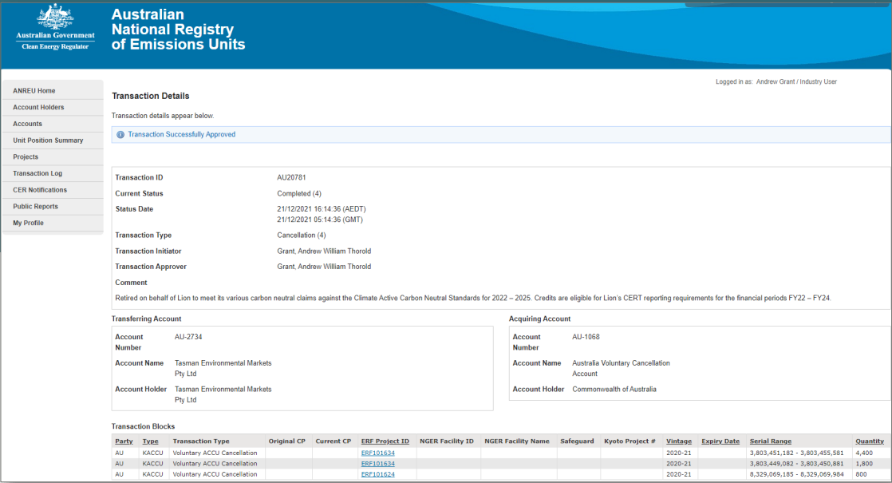
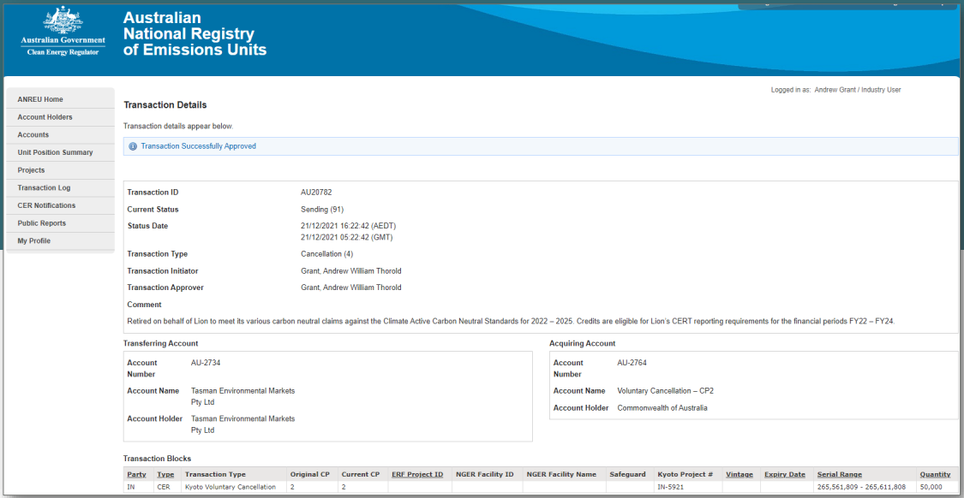
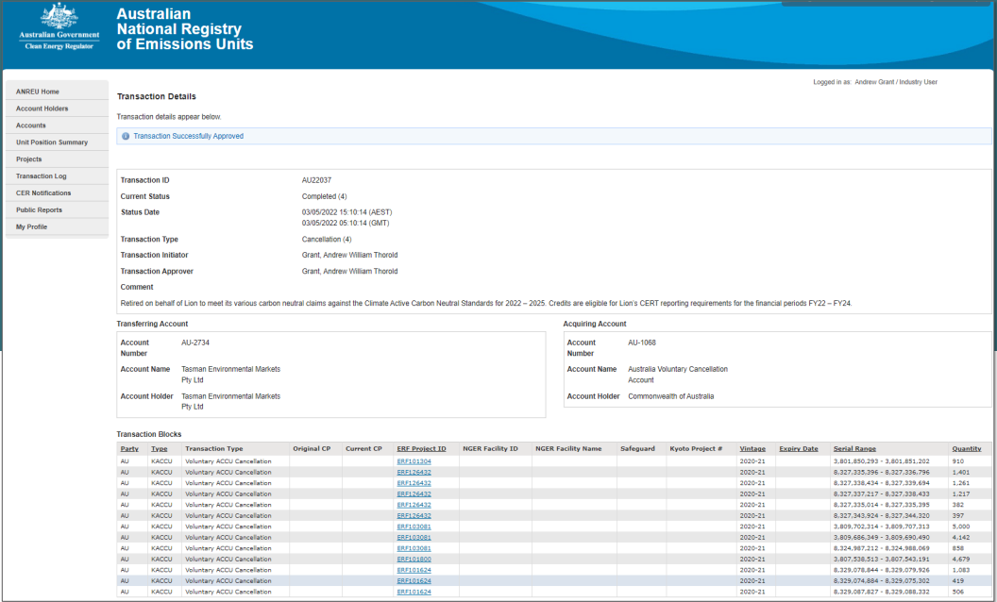
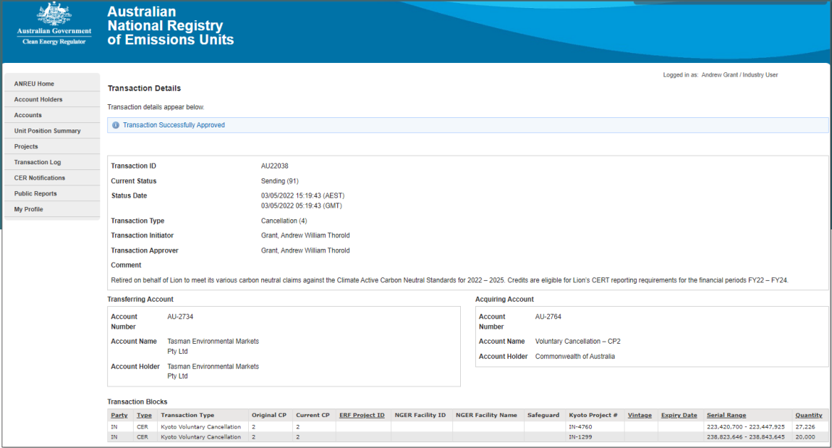

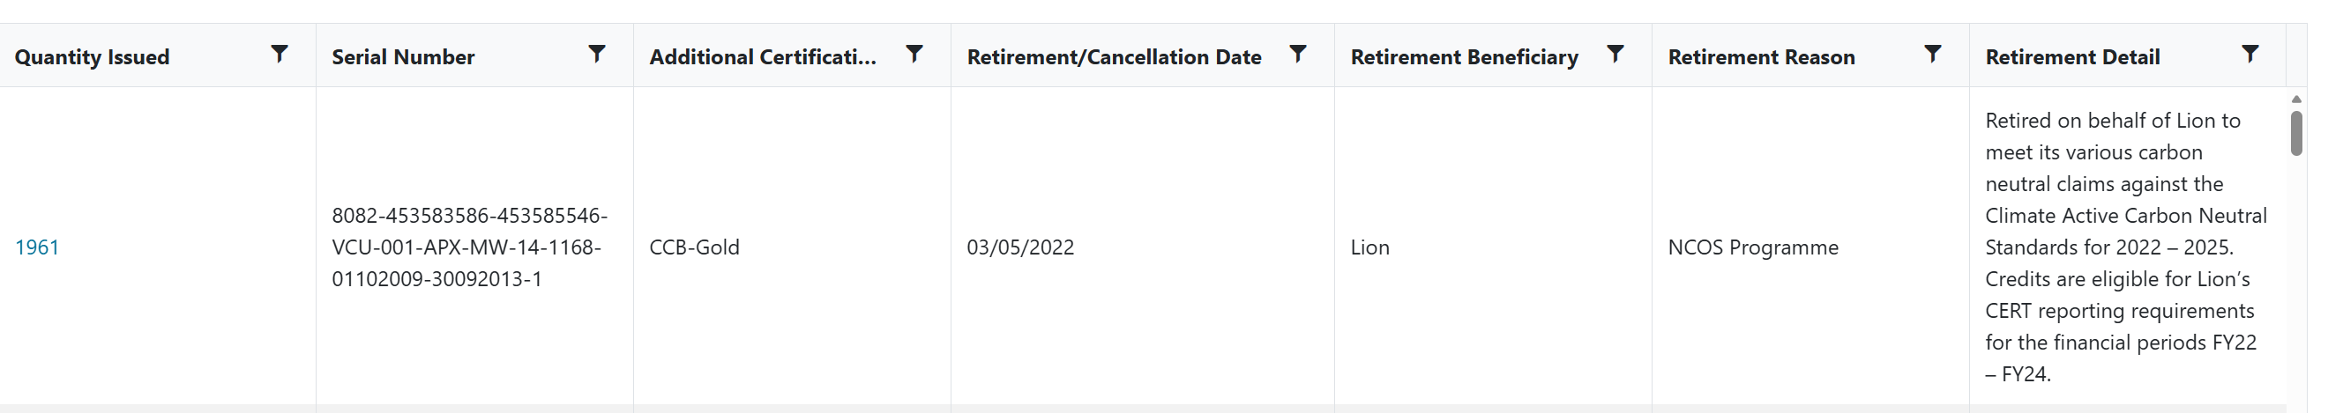

Co-benefits

Project Type: Active bushfire management of Arnhem Land, Australia
This project type utilizes active bushfire management methods by conducting controlled burns in wildfire-prone areas through the reduction of fuel on the ground and establishing natural firebreaks. The projects provide employment opportunities and supports Aboriginal people in returning to, remaining on and managing their country. Communities are supported through maintenance of Aboriginal culture and transfer of knowledge and the well being of traditional custodians.

Project Type: Wind power as a renewable source of electricity, India
Wind farms in India are replacing coal power, producing clean energy without emissions. They improve electricity availability, reduce blackouts, and support rural electrification. The projects also create jobs and build new roads, boosting local economies and accessibility.

Project Type: Human-Induced regeneration of native forests, Australia
This project type stores carbon by regenerating native forests. Additional benefits from these projects can include improved quality of rural land and water supply, increased biodiversity and shade and shelter for farmed livestock.

7. Renewable Energy Certificate (REC) Summary

Renewable Energy Certificate (REC) summary
The following RECs have been surrendered to reduce electricity emissions under the market-based reporting method.

- Large-scale Generation certificates (LGCs)* | 39,184
* LGCs in this table only include those surrendered voluntarily (including through PPA arrangements), and does not include those surrendered in relation to the LRET, GreenPower, and jurisdictional renewables.

Project supported by LGC purchase | Project location | Eligible unit type | Registry | Surrender date | Accreditation code | Certificate serial number | Generation year | Fuel source | Quantity (MWh)
Woolooga Solar Farm - Solar - QLD | QLD, Australia | LGC | REC Registry | 14 April 2025 | SRPVQLV0 | 36519-39275 | 2024 | Solar | 2757
Woolooga Solar Farm - Solar - QLD | QLD, Australia | LGC | REC Registry | 14 April 2025 | SRPVQLV0 | 136936-138354 | 2024 | Solar | 1419
Woodlawn Bioreactor LFG - NSW | NSW, Australia | LGC | REC Registry | 14 April 2025 | BEBGNS12 | 1147-1441 | 2021 | Landfill gas | 295
Woolooga Solar Farm - Solar - QLD | QLD, Australia | LGC | REC Registry | 14 April 2025 | SRPVQLV0 | 112697-114257 | 2024 | Solar | 1561
Woolooga Solar Farm - Solar - QLD | QLD, Australia | LGC | REC Registry | 14 April 2025 | SRPVQLV0 | 70839-72676 | 2024 | Solar | 1838
Woolooga Solar Farm - Solar - QLD | QLD, Australia | LGC | REC Registry | 14 April 2025 | SRPVQLV0 | 253676-256697 | 2023 | Solar | 3022
Woolooga Solar Farm - Solar - QLD | QLD, Australia | LGC | REC Registry | 14 April 2025 | SRPVQLV0 | 44017-45309 | 2024 | Solar | 1293
Woolooga Solar Farm - Solar - QLD | QLD, Australia | LGC | REC Registry | 14 April 2025 | SRPVQLV0 | 45310-46132 | 2024 | Solar | 823
Woolooga Solar Farm - Solar - QLD | QLD, Australia | LGC | REC Registry | 14 April 2025 | SRPVQLV0 | 145762-147787 | 2024 | Solar | 2026
Woolooga Solar Farm - Solar - QLD | QLD, Australia | LGC | REC Registry | 14 April 2025 | SRPVQLV0 | 159068-160221 | 2024 | Solar | 1154
Woolooga Solar Farm - Solar - QLD | QLD, Australia | LGC | REC Registry | 14 April 2025 | SRPVQLV0 | 116315-117874 | 2024 | Solar | 1560
Woolooga Solar Farm - Solar - QLD | QLD, Australia | LGC | REC Registry | 14 April 2025 | SRPVQLV0 | 82271-82790 | 2024 | Solar | 520
Woolooga Solar Farm - Solar - QLD | QLD, Australia | LGC | REC Registry | 14 April 2025 | SRPVQLV0 | 93612-94522 | 2024 | Solar | 911
Woolooga Solar Farm - Solar - QLD | QLD, Australia | LGC | REC Registry | 14 April 2025 | SRPVQLV0 | 120636-121604 | 2024 | Solar | 969
Woolooga Solar Farm - Solar - QLD | QLD, Australia | LGC | REC Registry | 14 April 2025 | SRPVQLV0 | 126661-129194 | 2024 | Solar | 2534
Woolooga Solar Farm - Solar - QLD | QLD, Australia | LGC | REC Registry | 14 April 2025 | SRPVQLV0 | 19530-20072 | 2024 | Solar | 543
Griffith Solar Farm - NSW - Solar | NSW, Australia | LGC | REC Registry | 14 April 2025 | SRPVNS90 | 58718-58731 | 2024 | Solar | 14
Griffith Solar Farm - NSW - Solar | NSW, Australia | LGC | REC Registry | 14 April 2025 | SRPVNS90 | 58464-58717 | 2024 | Solar | 254
Parkes Solar Farm - Solar - NSW | NSW, Australia | LGC | REC Registry | 14 April 2025 | SRPVNS88 | 86235-86550 | 2024 | Solar | 316
Griffith Solar Farm - NSW - Solar | NSW, Australia | LGC | REC Registry | 14 April 2025 | SRPVNS90 | 6867-7948 | 2025 | Solar | 1082
Griffith Solar Farm - NSW - Solar | NSW, Australia | LGC | REC Registry | 14 April 2025 | SRPVNS90 | 1-6852 | 2025 | Solar | 6852
Parkes Solar Farm - Solar - NSW | NSW, Australia | LGC | REC Registry | 14 April 2025 | SRPVNS88 | 1-7441 | 2025 | Solar | 7441
Total LGCs surrendered this report and used in this report |  |  |  |  |  |  |  |  | 39,184

Appendix A: Additional Information
N/A

Appendix B: Electricity summary
There are two international best-practice methods for calculating electricity emissions – the location-based method and the market-based method. Reporting electricity emissions under both methods is called dual reporting.
Dual reporting of electricity emissions is useful, as it provides different perspectives of the emissions associated with a business’s electricity usage.
Location-based method:
The location-based method provides a picture of a business’s electricity emissions in the context of its location, and the emissions intensity of the electricity grid it relies on. It reflects the average emissions intensity of the electricity grid in the location (State) in which energy consumption occurs. The location-based method does not allow for any claims of renewable electricity from grid-imported electricity usage.
Market-based method:
The market-based method provides a picture of a business’s electricity emissions in the context of its renewable energy investments. It reflects the emissions intensity of different electricity products, markets and investments. It uses a residual mix factor (RMF) to allow for unique claims on the zero emissions attribute of renewables without double-counting.
For this certification, electricity emissions have been set by using the market-based approach.

Lion Pty Ltd Organisation certification is the parent certification and has a Parent-Child relationship with the Four Pillars Gin and XXXX Zero product certification. As such, the Lion certification captures shared electricity usage between the Lion Pty Ltd and Four Pillars Gin and XXXX Zero for the overlapping reporting boundaries.

Market-based approach summary
Market Based Approach | Activity Data (kWh) | Emissions  (kg CO₂-e) | Renewable Percentage of total
Behind the meter consumption of electricity generated | 1,810,699 | 0 | 4%
Total non-grid electricity | 1,810,699 | 0 | 4%
LGC purchased and retired (kWh) (including PPAs) | 39,184,000 | 0 | 79%
GreenPower | 0 | 0 | 0%
Climate Active certified - Precinct/Building (voluntary renewables) | 0 | 0 | 0%
Climate Active certified - Precinct/Building (LRET) | 0 | 0 | 0%
Climate Active certified - Precinct/Building jurisdictional renewables (LGCs surrendered) | 0 | 0 | 0%
Climate Active certified - Electricity products (voluntary renewables) | 0 | 0 | 0%
Climate Active certified - Electricity products (LRET) | 0 | 0 | 0%
Climate Active certified - Electricity products jurisdictional renewables (LGCs surrendered) | 0 | 0 | 0%
Jurisdictional renewables (LGCs surrendered) | 0 | 0 | 0%
Jurisdictional renewables (LRET) (applied to ACT grid electricity) | 0 | 0 | 0%
Large Scale Renewable Energy Target (applied to grid electricity only) | 8,799,131 | 0 | 18%
Residual electricity | -368,785 | -335,595 | 0%
Total renewable electricity (grid + non grid) | 49,793,830 | 0 | 101%
Total grid electricity | 47,614,346 | 0 | 97%
Total electricity (grid + non grid) | 49,425,045 | 0 | 101%
Percentage of residual electricity consumption under operational control | 100%
Residual electricity consumption under operational control | -368,785 | -335,595
Scope 2 | -328,259 | -298,716
Scope 3 (includes T&D emissions from consumption under operational control) | -40,526 | -36,879
Residual electricity consumption not under operational control | 0 | 0
Scope 3 | 0 | 0

Total renewables (grid and non-grid) | 100.75%
Mandatory | 17.80%
Voluntary | 79.28%
Behind the meter | 3.66%
Residual scope 2 emissions (t CO₂-e) | -298.72
Residual scope 3 emissions (t CO₂-e) | -36.88
Scope 2 emissions liability (adjusted for already offset carbon neutral electricity) (t CO₂-e) | 0.00
Scope 3 emissions liability (adjusted for already offset carbon neutral electricity) (t CO₂-e) | 0.00
Total emissions liability (t CO₂-e) | 0.00
Figures may not sum due to rounding. Renewable percentage can be above 100%

Location-based approach summary
Location-based approach | Activity Data (kWh) total | Under operational control |  |  | Not under operational control
Percentage of grid electricity consumption under operational control | 100% | (kWh) | Scope 2 Emissions (kg CO₂-e) | Scope 3 Emissions (kg CO₂-e) | (kWh) | Scope 3 Emissions  (kg CO₂-e)
ACT | 0 | 0 | 0 | 0 | 0 | 0
NSW | 21,031,474 | 21,031,474 | 14,301,402 | 1,051,574 | 0 | 0
SA | 89,282 | 89,282 | 22,321 | 7,143 | 0 | 0
VIC | 3,042,012 | 3,042,012 | 2,403,190 | 212,941 | 0 | 0
QLD | 18,067,659 | 18,067,659 | 13,189,391 | 2,710,149 | 0 | 0
NT | 13,010 | 13,010 | 7,025 | 911 | 0 | 0
WA | 1,669,207 | 1,669,207 | 884,680 | 66,768 | 0 | 0
TAS | 3,701,701 | 3,701,701 | 444,204 | 37,017 | 0 | 0
Grid electricity (scope 2 and 3) | 47,614,346 | 47,614,346 | 31,252,213 | 4,086,502 | 0 | 0
ACT | 0 | 0 | 0 | 0
NSW | 243,019 | 243,019 | 0 | 0
SA | 0 | 0 | 0 | 0
VIC | 667,680 | 667,680 | 0 | 0
QLD | 900,000 | 900,000 | 0 | 0
NT | 0 | 0 | 0 | 0
WA | 0 | 0 | 0 | 0
TAS | 0 | 0 | 0 | 0
Non-grid electricity (behind the meter) | 1,810,699 | 1,810,699 | 0 | 0
Total electricity (grid + non grid) | 49,425,045

Residual scope 2 emissions (t CO₂-e) | 31,252.21
Residual scope 3 emissions (t CO₂-e) | 4,086.50
Scope 2 emissions liability (adjusted for already offset carbon neutral electricity) (t CO₂-e) | 31,252.21
Scope 3 emissions liability (adjusted for already offset carbon neutral electricity) (t CO₂-e) | 4,086.50
Total emissions liability (t CO₂-e) | 35,338.71

Operations in Climate Active buildings and precincts

Operations in Climate Active buildings and precincts | Electricity consumed in Climate Active certified building/precinct (kWh) | Emissions  (kg CO₂-e)
N/A | 0 | 0
Climate Active carbon neutral electricity is not renewable electricity. These electricity emissions have been offset by another Climate Active member through their building or precinct certification. This electricity consumption is also included in the market based and location-based summary tables. Any electricity that has been sourced as renewable electricity by the building/precinct under the market-based method is outlined as such in the market-based summary table.

Climate Active carbon neutral electricity products

Climate Active carbon neutral electricity product used | Electricity claimed from Climate Active electricity products (kWh) | Emissions  (kg CO₂-e)
N/A | 0 | 0
Climate Active carbon neutral electricity is not renewable electricity. These electricity emissions have been offset by another Climate Active member through their electricity product certification. This electricity consumption is also included in the market based and location-based summary tables. Any electricity that has been sourced as renewable electricity by the electricity product under the market-based method is outlined as such in the market-based summary table.

Appendix C: Inside emissions boundary

Non-quantified emission sources
The following emissions sources have been assessed as relevant, are captured within the emissions boundary, but are not measured (quantified) in the carbon inventory. They have been non-quantified due to one of the following reasons:
- Immaterial <1% for individual items and no more than 5% collectively
- Cost effective Quantification is not cost effective relative to the size of the emission but uplift applied.
- Data unavailable Data is unavailable but uplift applied. A data management plan must be put in place to provide data within 5 years.
- Maintenance Initial emissions non-quantified but repairs and replacements quantified.
Relevant non-quantified emission sources | Justification reason
N/A | N/A

Data management plan for non-quantified sources
There are no non-quantified sources in the emission boundary that require a data management plan.

Appendix D: Outside emissions boundary

Excluded emission sources
The below emission sources have been assessed as not relevant to this organisation’s operations and are outside of its emissions boundary. These emissions are not part of the carbon neutral claim. Emission sources considered for relevance must be included within the certification boundary if they meet two of the five relevance criteria. Those which only meet one condition of the relevance test can be excluded from the certification boundary.
Emissions tested for relevance are detailed below against each of the following criteria:
- Size The emissions from a particular source are likely to be large relative to the organisation’s electricity, stationary energy and fuel emissions.
- Influence The responsible entity has the potential to influence the reduction of emissions from a particular source.
- Risk The emissions from a particular source contribute to the organisation’s greenhouse gas risk exposure.
- Stakeholders Key stakeholders deem the emissions from a particular source are relevant.
- Outsourcing The emissions are from outsourced activities previously undertaken within the organisation’s boundary, or from outsourced activities typically undertaken within the boundary for comparable organisations.

Excluded emissions sources summary
Emission sources tested for relevance | Size | Influence | Risk | Stakeholders | Outsourcing | Justification
IT Services | Y | N | N | N | N | Size: The emissions source is likely to be large compared the organisation’s electricity, stationary energy and fuel emissions of 21,994 tCO₂-e but not in the organisation’s direct control.  Influence: We do not have the potential to influence the emissions from this source, including by shifting to a different lower-emissions supplier for our business.  Risk: There are no relevant laws or regulations that apply to limit emissions specifically from this source, the source does not create supply chain risks, and it is unlikely to be of significant public interest.  Stakeholders: Key stakeholders, including the public, are unlikely to consider this a relevant source of emissions for our business as they are expected to focus on high-impact sources of direct emissions such as electricity and fuel.  Outsourcing: We have not previously undertaken this activity within our emissions boundary and comparable organisations do not typically undertake this activity within their boundary.
Event catering | N | N | N | N | N | Size: The emissions source is likely to be immaterial, which is not large compared to the organisation’s electricity, stationary energy and fuel emissions of 21,994 tCO₂-e .  Influence: We do not have the potential to influence the emissions from this source, including by shifting to a different lower-emissions supplier for our business.  Risk: There are no relevant laws or regulations that apply to limit emissions specifically from this source, the source does not create supply chain risks, and it is unlikely to be of significant public interest.  Stakeholders: Key stakeholders, including the public, are unlikely to consider this a relevant source of emissions for our business.  Outsourcing: We have not previously undertaken this activity within our emissions boundary and comparable organisations do not typically undertake this activity within their boundary.
Maintenance | Y | N | N | N | N | Size: The emissions source is likely to be large compared the organisation’s electricity, stationary energy and fuel emissions of 21,994 tCO₂-e but not in the organisation’s direct control.  Influence: We do not have the potential to influence the emissions from this source, including by shifting to a different lower-emissions supplier for our business.  Risk: There are no relevant laws or regulations that apply to limit emissions specifically from this source, the source does not create supply chain risks, and it is unlikely to be of significant public interest.  Stakeholders: Key stakeholders, including the public, are unlikely to consider this a relevant source of emissions for our business as they are expected to focus on high-impact sources of direct emissions such as electricity and fuel.  Outsourcing: We have not previously undertaken this activity within our emissions boundary and comparable organisations do not typically undertake this activity within their boundary.
Purchased services | Y | N | N | N | N | Size: The emissions source is likely to be large compared the organisation’s electricity, stationary energy and fuel emissions of 21,994 tCO₂-e but not in the organisation’s direct control.  Influence: We do not have the potential to influence the emissions from this source, including by shifting to a different lower-emissions supplier for our business.  Risk: There are no relevant laws or regulations that apply to limit emissions specifically from this source, the source does not create supply chain risks, and it is unlikely to be of significant public interest.  Stakeholders: Key stakeholders, including the public, are unlikely to consider this a relevant source of emissions for our business as they are expected to focus on high-impact sources of direct emissions such as electricity and fuel.  Outsourcing: We have not previously undertaken this activity within our emissions boundary and comparable organisations do not typically undertake this activity within their boundary.
Cleaning | Y | N | N | N | N | Size: The emissions source is likely to be large compared the organisation’s electricity, stationary energy and fuel emissions of 21,994 tCO₂-e but not in the organisation’s direct control.  Influence: We do not have the potential to influence the emissions from this source, including by shifting to a different lower-emissions supplier for our business.  Risk: There are no relevant laws or regulations that apply to limit emissions specifically from this source, the source does not create supply chain risks, and it is unlikely to be of significant public interest.  Stakeholders: Key stakeholders, including the public, are unlikely to consider this a relevant source of emissions for our business as they are expected to focus on high-impact sources of direct emissions such as electricity and fuel.  Outsourcing: We have not previously undertaken this activity within our emissions boundary and comparable organisations do not typically undertake this activity within their boundary.
Consumables | N | N | N | N | N | Size: The emissions source is likely to be immaterial, which is not large compared the organisation’s electricity, stationary energy and fuel emissions of 21,994 tCO₂-e .  Influence: We do not have the potential to influence the emissions from this source, including by shifting to a different lower-emissions supplier for our business.  Risk: There are no relevant laws or regulations that apply to limit emissions specifically from this source, the source does not create supply chain risks, and it is unlikely to be of significant public interest.  Stakeholders: Key stakeholders, including the public, are unlikely to consider this a relevant source of emissions for our business as they are expected to focus on high-impact sources of direct emissions such as electricity and fuel.  Outsourcing: We have not previously undertaken this activity within our emissions boundary and comparable organisations do not typically undertake this activity within their boundary.
Downstream emissions | Y | N | N | N | N | Size: The emissions source is material, however not within the organisations direct control.  Influence: We do not have the potential to influence the emissions from this source, including by shifting to a different lower-emissions supplier for our business.  Risk: There are no relevant laws or regulations that apply to limit emissions specifically from this source, the source does not create supply chain risks, and it is unlikely to be of significant public interest.  Stakeholders: Key stakeholders, including the public, are unlikely to consider this a relevant source of emissions for our business as they are expected to focus on high-impact sources of direct emissions such as electricity and fuel.  Outsourcing: We have not previously undertaken this activity within our emissions boundary. Downstream emissions are captured in product certifications.
Capital goods | Y | N | N | N | N | Size: The emissions source is likely to be large compared the organisation’s electricity, stationary energy and fuel emissions of 21,994 tCO₂-e but not in the organisation’s operations.  Influence: We do not have the potential to influence the emissions from this source, including by shifting to a different lower-emissions supplier for our business.  Risk: There are no relevant laws or regulations that apply to limit emissions specifically from this source, the source does not create supply chain risks, and it is unlikely to be of significant public interest.  Stakeholders: Key stakeholders, including the public, are unlikely to consider this a relevant source of emissions for our business as they are expected to focus on high-impact sources of direct emissions such as electricity and fuel.  Outsourcing: We have not previously undertaken this activity within our emissions boundary and comparable organisations do not typically undertake this activity within their boundary.
Raw materials | Y | N | N | N | N | Size: The emissions source is material, however, the emissions from raw materials are not within the organisations direct control.  Influence: We do not have the potential to influence the emissions from this source, including by shifting to a different lower-emissions supplier for our business.  Risk: There are no relevant laws or regulations that apply to limit emissions specifically from this source, the source does not create supply chain risks, and it is unlikely to be of significant public interest.  Stakeholders: Key stakeholders, including the public, are unlikely to consider this a relevant source of emissions for our business as these would be captured in product certifications.  Outsourcing: We have not previously undertaken this activity within our emissions boundary. Upstream emissions are captured in product certifications.
Packaging materials | Y | N | N | N | N | Size: The emissions source is material, however, the emissions from packaging materials are not within the organisations direct control.  Influence: We do not have the potential to influence the emissions from this source, including by shifting to a different lower-emissions supplier for our business.  Risk: There are no relevant laws or regulations that apply to limit emissions specifically from this source, the source does not create supply chain risks, and it is unlikely to be of significant public interest.  Stakeholders: Key stakeholders, including the public, are unlikely to consider this a relevant source of emissions for our business as these would be captured in product certifications.  Outsourcing: We have not previously undertaken this activity within our emissions boundary. Upstream emissions are captured in product certifications.
Use of Products | N | N | N | N | N | Size: The emissions source is likely to be immaterial, which is not large compared the organisation’s electricity, stationary energy and fuel emissions of 21,994 tCO₂-e .  Influence: We do not have the potential to influence the emissions from this source, including by shifting to a different lower-emissions supplier for our business.  Risk: There are no relevant laws or regulations that apply to limit emissions specifically from this source, the source does not create supply chain risks, and it is unlikely to be of significant public interest.  Stakeholders: Key stakeholders, including the public, are unlikely to consider this a relevant source of emissions for our business.  Outsourcing: Consuming our own products is generally not undertaken within our boundary and comparable organisations do not typically undertake this activity within their boundary.
Product Distribution Upstream & Downstream | Y | N | N | N | N | Size: The emissions source is material, however, the emissions from distribution are not within the organisations direct control.  Influence: We do not have the potential to influence the emissions from this source, including by shifting to a different lower-emissions supplier for our business.  Risk: There are no relevant laws or regulations that apply to limit emissions specifically from this source, the source does not create supply chain risks, and it is unlikely to be of significant public interest.  Stakeholders: Key stakeholders, including the public, are unlikely to consider this a relevant source of emissions for our business as these would be captured in product certifications.  Outsourcing: We have not previously undertaken this activity within our emissions boundary. Distribution emissions are captured in product certifications.
International Operations | Y | N | N | N | N | Size: The emissions source is likely to be material.  Influence: We do not have the potential to influence the emissions from this source, including by shifting to a different lower-emissions supplier for our business.  Risk: There are no relevant laws or regulations that apply to limit emissions specifically from this source, the source does not create supply chain risks, and it is unlikely to be of significant public interest.  Stakeholders: Key stakeholders, including the public, are unlikely to consider this a relevant source of emissions for our business as those markets have their own carbon neutral certification scheme and this certification is limited to Lion’s Australian operations.  Outsourcing: We have not previously undertaken this activity within our emissions boundary and comparable organisations would not typically undertake this activity within their boundary.
Wastewater treatment fugitive emissions | Y | N | N | N | N | The wastewater treatment train at Lion sites are a closed anaerobic followed by aerobic processes. The methane released through the anaerobic digestion step is captured and used as a natural gas substitute in the breweries. The aerobic process step has a methane correction factor of zero.  Size: The emissions estimated by the NGER calculator is material. The NGER method used determines a nominal total methane released in the system by multiplying the recorded captured methane mass by 1.25x, thereby creating a fugitive methane emission which is reported.  Influence: We do not have the potential to influence the emissions from this source in practice, other than using a different estimation method.  Risk: The wastewater treatment systems are subject to Environmental Protection Authority approvals and HAZOP controls designed to shut down the wastewater treatment plant if the instrumentation detects any fugitive methane emissions.  Stakeholders: Key stakeholders, including the public, are unlikely to consider this a relevant source of emissions for our business and comparable organisations do not typically undertake this activity within their boundary.  Outsourcing: We have not previously undertaken this activity within our emissions boundary



